Canopi Online Pty Ltd

[Course Name]

Draft Functional Specifications

Document Details

Version | Version 1
Last modified | 1 September 2013
Last Modified by | Greg McLoughlin-Wilden
Document status | Final
Approved by | Greg McLoughlin-Wilden
Approved Date | 1 September 2013
Owner | Canopi Online Pty Ltd
Documents location | /Canopi Clients/[Client]/[Course Name]

Acceptance page for signing is located on the last page of this document

Revision History
Interim version are permissible and are used to refine comments and input.

Date | Version | Modified By | Description
28/6/2012 | 1.0 | GMW | Draft Functional Specification
01-03-2011 | 2.0 |  | Clients Comments included
01-03-2011 | 3.0 |  | Final Version

Table of Contents
Document Details 2
Revision History 2
Table of Contents 3
Project Details 4
Key personnel 4
Project owner – ASC 4
Project Manager – Canopi Online Pty Ltd 4
Project Manager – Janison 4
Background 5
Target Audience 5
Learner characteristics 5
Functional Specification 6
Screen Details 6
Web Browsers 6
Operating Systems 6
Plugin’s 6
User connections and streaming implications 6
Colour Selection 7
Font selection 8
Navigation styles 8
Look and feel 9
Delivery System 10
Enrolment 10
Accessibility requirements 10
Nomenclature 10
Tracking and progress certificates 11
Printing 11
Timelines 11
Checklist ‘Help’ pages 11
Data Importing? 11

Project Details

Key personnel

Client details

Name
Title
Organisation
Tel: (02) 6654 3689
Fax: (02) 6654 3698
Email:
Address:

Project Manager – Canopi Online Pty Ltd

Greg McLoughlin-Wilden
Canopi Online Pty Ltd
Tel: (02) 6654 3689
Fax: (02) 6654 3698
greg@canopi.com.au
PO Box 207, Nana Glen NSW, 2450

Project Manager – Janison

Niels Grootscholten
Business Manager
Janison Solutions
Tel: (02) 8307 0812
Fax: (02) 6652 9855
ngrootscholten@janison.com.au
PO Box 4289
Coffs Harbour NSW 2450

Background
The [Course Name] program is

The main themes of the program are:

- Theme 1
- Theme 2
- Theme 3

The online courses will be hosted on the [Clients] Janison CLS portal.

Target Audience
In general users will be expected to have computer literacy at a level that will enable them to:

- Use a browser
- Navigate around a web page
- Click on links
- Open email attachments

Learner characteristics

The initial audience for the course is ….

They may have the following characteristics:

Functional Specification

Screen Details
- 1280 x 1024
- 32 bit colour system creating over 16,000 colours

Supported Web Browsers
- PC, Microsoft Internet Explorer 8.0+
- PC, FireFox 21+
- Mac FireFox 21+
- Safari 5.0+
- Mobile Safari for the iPad
All Browsers must be java script enable
Cookies must be enabled

Operating Systems
- Windows XP, Windows Vista, Windows 7, Windows 8
- Macintosh OS 9+

Plugin’s
- PDF Reader

User connections and streaming implications

The Courseware will be developed to run across a 1.5m/sec ADLS modem. Individual page downloads will be kept under 5 seconds excluding video screens if applicable. A download screen/graphic will be included in cases where users need to wait for a download.

The speed of individual transactions within the site will not take more than seven seconds.

Colour Selection
The [Course Name] course will have the same basic colour scheme as the existing [client] branding and eLearning subportal. The table below contains the colour selections available. Variations of these colours may be used to bleed from one colour to another or as a shading option in backgrounds.

DO NOT sample the colours from this page as Microsoft word can vary the RGB colour values.

Swatch | RGB Colour | Hexadecimal | Used for
Primary colour palette

Font selection
The [client] has a selection of fonts associated with their corporate branding. A table of these fonts is included below. Any font selection within the course should be based on these fonts’ and sizes.

Style name | Font & Style | Size | Colour

Look and feel
The look and feel of the site will be based on the Janison CLS courseware player but in the [clients] colour scheme.

The key features of this design are:
- Schema Navigation bar at top of page showing the course and module, and allowing ‘Course Editors’ to edit the content or set progress status remarks.
- A screen navigation bar, that shows a thumbnail for each screen
- A content panel that is can be split into 1,2, or 3 screen regions based on HTML template files.
- The ability to define content types for each panel, that are detailed in Appendix ‘A’
- A next and previous navigation structure.

Delivery System
The course will be designed to run within the Janison CLS, and access granted through the [clients] eLearning portal.

The Course will be developed and tested on the Canopi development server located at http://development.canopi.janison.com and after final acceptance and testing has been completed will be loaded onto the clients server as

The title of the course will be:
- [Course Name]

The titles and order of the modules will be;
- Introduction
- Module 1
- Module 2
- Module 3
- Module 4
- Etc.

Enrolment
Enrolment in the course will be via the [client] eLearning portal located at [URL]
Learners will be able to register on the portal and then;
- Request an enrolment and be approved by manager
- Request enrolment and be approved by administrator
- Request enrolment and be approved by manager then by administrator
- Request enrolment and then be approved by manager and then approved by their manager
- Be enrolled by an administrator
- Enrol for free and get immediate access
- Enrol using a credit card and get immediate access
- Enrol using a token and get immediate access
- Enrol on the Membership system and be automatically enrolled in the course
- Auto assigned the course

Accessibility requirements
All clickable items will be able to be navigated and selected through tab and enter keys as described by the W3C standards.

The course is to be developed to the W3C consortiums WCAG 2.0 guidelines defined at www.w3.org The course will comply with all Priority 1 and 2 items.

Section 1 - Perceivable
- Guideline 1.1 - Provide text alternatives for non-text content.
- Guideline 1.2 - Provide captions and alternatives for time based media.
- Guideline 1.3 - Make content adaptable; and make it available to assistive technologies.
- Guideline 1.4 - Use sufficient contrast to make things easy to see and hear.

Section 2 - Operable
- Guideline 2.1 - Make all functionality keyboard accessible.
- Guideline 2.2 - Give users enough time to read and use content.
- Guideline 2.3 - Do not use content that causes seizures.
- Guideline 2.4 - Help users navigate and find content.

Section 3 - Understandable
- Guideline 3.1 - Make text readable and understandable.
- Guideline 3.2 - Make content appear and operate in predictable ways.
- Guideline 3.3 - Help users avoid and correct mistakes.

Section 4 - Robust
- Guideline 4.1 - Maximize compatibility with current and future technologies.

Nomenclature
Below is a list of the naming conventions to be used throughout the course.

Course Name: [Course Name]
Structure: A ‘Course’ with five ‘Modules’.
Course: Is the whole [Course Name] with five modules
Prefix: The prefix for all course resources will be ‘abc’
A Module: Is one of the five sections of the course. A module contains pages and on those pages can be a range of content from text, images, video’s interactions and links to other resources.
Module 1: Introduction (all leading caps)
Module 2: Title
Module 3: Title
Module 4: Title
Module 5: Summary (all leading caps)
Host: The Host of the course is [Client]. It may be abbreviated to the [abbreviation] within each topic after it has been described in full within that topic.
Owner: The owner of the Content is [Client]
File names: All file names will be prefixed by ‘[prefix]’ all in lower case, and no spaces.
Page names will be referenced from the map and carry the sequence code, so a page called 0101 will be called ‘[prefix]0101.asp’
Resource names: All resources associated with a page will be called the page name with a sequential alpha character as in a, b, c, etc.
example.
[prefix]0101a.jpg – The first resource, an image
[prefix]101b.swf – The second resource, a flash file
[prefix]0101c.doc – The third resource, a Word document
if a resource is used in two places then there will be two copies of the resource made, named in the appropriate manner, rather than reference a single resource from multiple locations.
Generic resources: Any generic resources that exist for the purpose of the whole course will be named by their purpose.
eg.
[prefix]help1.asp – The first page of the help files
Module resources: Any resource that is created for use across a module will contain the module number in its name.
eg.
[prefix]01N1.jpg – The first navigation image in module 1
[prefix]01N1.jpg – The second navigation image in module 1
[prefix]02N1.jpg – The first navigation image in module 2

Avoid

Never use the words Subject, Unit, Element, Group, or Section to describe the structure within the Course.

Never use the word Test or Survey in reference to an assessment feedback.

Tracking and progress certificates

- At the Course level (on the portal):
The first screen (portal home) Will list all of the enrolled course and show:
    - the current enrolment status
    - the current completion progress
    - a link to a completion certificate
- At the module level:
When a user selects the “[Course Name]” course from the main menu on the [clients] portal they will be shown the five modules in a tile format similar to the Play by the Rules course player. Each tile will have the module details, a clickable overview of the module, the current progress and a link to start the module.

- Completion certificates:
When a user completes the course they will be able to print out a Completion certificate from the [Course Name] course homepage.
- [Client] will be able to export learner data from the learning management system into CSV files. The [client] learning portal has standard reports that can be exported in text delimited format. If [client] require other formats for the report they can advise Canopi Online of their report requirements and we will generate a report.
- Project staff from [client] can be setup on the platform to have report permissions for the course. With these permissions the user will be able to run Enrolment, completions and activity reports.
- Completion of the modules and topics will be established by the user having worked through every page in the module and passing any assessment.

Timelines

The timelines for the development of the course are:

Milestones | Date
1. Functional Specification delivered
2. Functional Specification sign off
3. Storyboards delivered
4. Storyboard sign off
5. Filming
6. Content loaded
7. Beta Testing
8. Loaded to live Site
9. Final Acceptance and testing

Content Map

Learning Design
Include a description and structure of the learning design here.

Sign off

This functional specification has been read and accepted on behalf of [client].

We acknowledge that it is a true reflection of our requirement under the contract for the development of the [Course Name] Program with Canopi Online Pty Ltd.

Name: ______________________________

Position: ______________________________

Date: ___ / ___ / ___

Appendix ‘A’ – Panel templates

Text panel
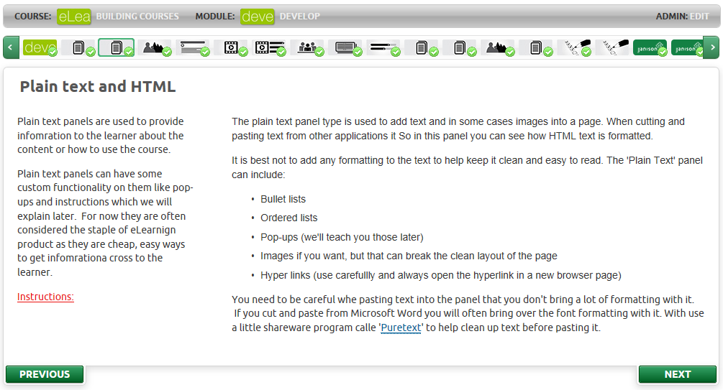
A text panel allows for HTML text to be displayed within a page.
The HTML can contain:
- Pop-up dialogue boxes
- A ‘Click’ to manually complete the page
- Reveal bullet and ordered lists
- Normal bullet and ordered lists
- Hyperlinks
- JavaScript and other client side scripting
- CSS styles
- Bold and italicised text
- images

Image Panel
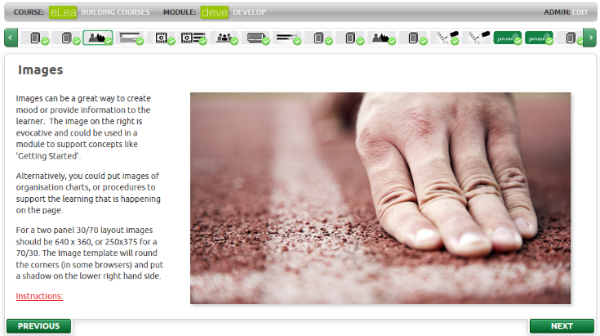
The image panel is a dedicated panel type for displaying images.
An Image panel:
- Displays a selected image
- Resize a selected image
- Places a drop shadow on the image
- In some browsers is can place curves corners on the image
- Present ‘Alt’ text for the image

Accordion/tab panels
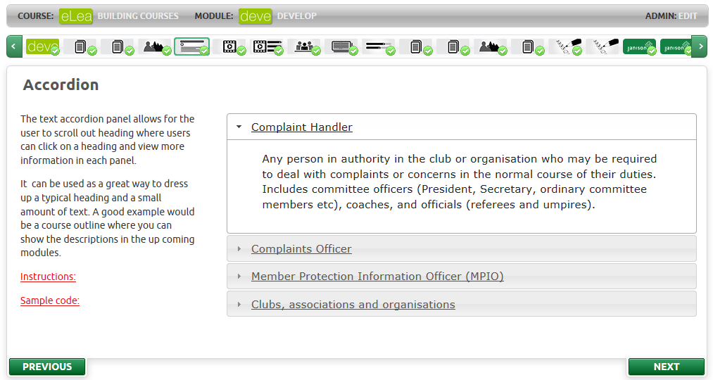
Accordion panels group content by headings and can display as either accordion headings, Vertical tabs, or horizontal tabs.
An accordion panel can:
- Complete when visited
- Complete when one heading is selected
- Complete when all headings have been selected
- Have accordion bars
- Have horizontal tabs
- Have vertical tabs

Image slideshow
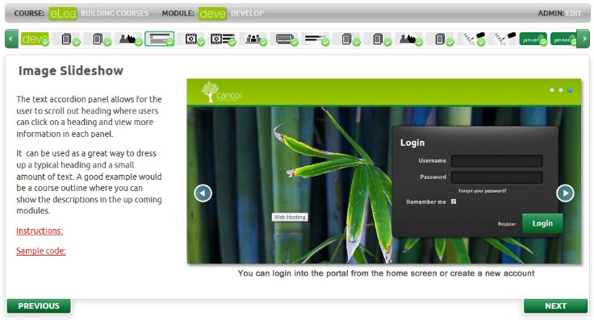
An image slideshow can present a series of images that can be navigated by the learner.
An image slideshow can:
- Show an unlimited number of images
- Fade or slide through transitions
- Fade through different colours
- Contain a caption for each slide
- Set the page to complete when viewed
- Set the page to complete when one extra slide is viewed
- Set the page to complete when all slides are viewed
- Have different times set for each transitions

Video Panels
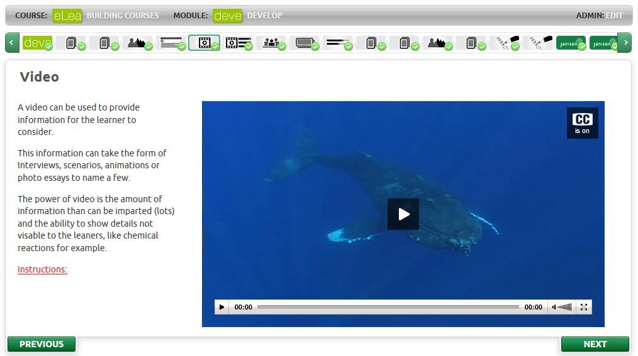
A video panel plays an encoded video with subtitles.
A video panel can:
- Play an Mp4 video encoded with the H.264 codec (this ensures tablet playback)
- Be resized, but 640 x 360 works best
- Contain a captions file
- Have ALT text
- Have a place holder image before the video starts playing

Video Case study
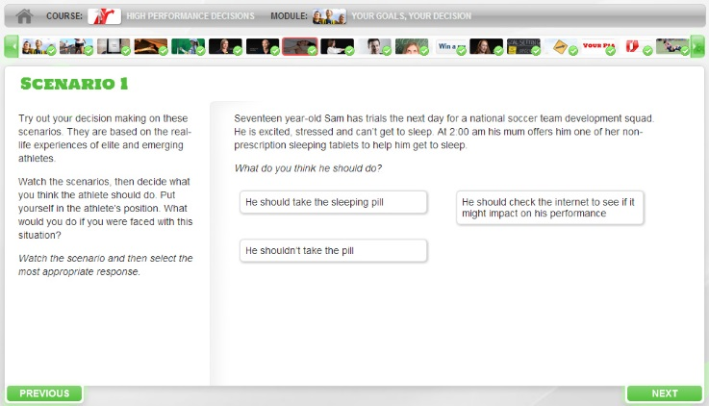
A video case study can display a series of video’s to the learner and between each one ask them questions which are scored correct or incorrect.
A video case study can:
- Display MP4 videos
- Have up to 6 distractors
- Have 1 correct answer
- Ask the learner to retry, or start from the beginning again.
- Mark the page the page as complete when they have answered all questions correctly.

Hotspot
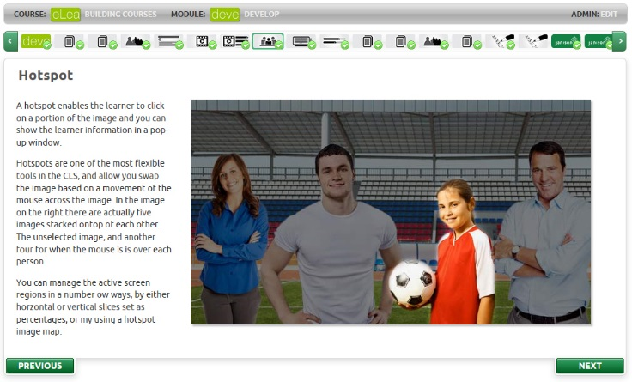
An image hotspot contains a background image that defines areas of the screen that be can be highlighted when the mouse goes over them.
When a region is selected, the screen can show a pop up.
An image hotspot can:
- Can a stacked offset image to show different images depending on the region of the screen selected
- Support x, y regions
- Support vertical slices
- Support horizontal slices
- Generate a pop-up box with HTML text when a region is clicked

Free text input
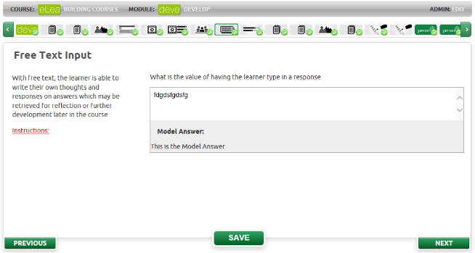
The free text input box allows the learner to type in information for submission or self-reflection.
A model answer can be supplied to the learner after they submit their answer.
A free text input can:
- Accept an unlimited number of characters
- Provide a model answer to the learner when they click ‘Save’

Poll questions
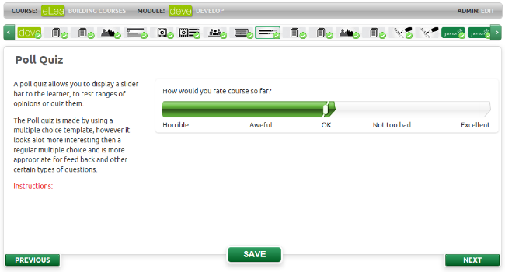
A poll question allows the learner to select a response to a Multiple Choice question and have it presented as sliding bar, which represents a continuum of possible answers.
A poll can:
- Have up to 5 distractors
- Provide feedback on each selection
- Have more than one poll per panel (5 is about the best maximum, but there is no limit.)

Reflection tiles
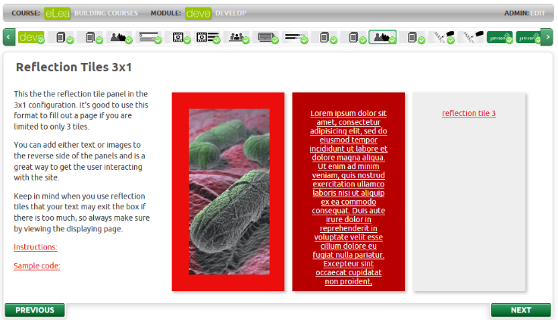
A reflection tile allows the learner to be presented with questions or suppositions, and they flip over the tile to see if they got it correct.
A reflection tile can:
- Have text on either side
- Have an image on either side
- Have the edge padding changed
- Have two possible distractors on the front
- Have different feedback based on the distractor
- Be used in a micro quiz
- Have any number of x and y tiles

Micro quiz
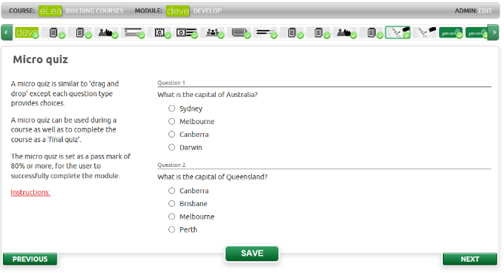
A micro quiz panel allows for questions to be posed to the learner.
A micro quiz can:
- Have multiple choice questions
- Have multiple choices questions
- Have flip tile questions, but the whole quiz must contain just flip tile questions.
- Have any score as a pass mark including zero
- Provide pass/fail feedback at the quiz level
- Provide pass/fail feedback at the question level
- The page only completes when they pass the quiz

Checkbox toggle
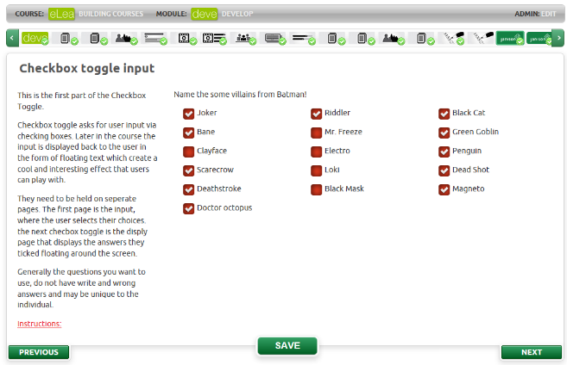
The check box toggle a differently rendered multiple choices question type that allows the learner to select values and have them redisplayed at a later part of the module. These make good self-reflection exercises as in “Here is what you chose earlier”
A checkbox toggle can:
- Show an unlimited number of choices to the learner
- Have them select as many options as they want
- Play back those selections on a later page

Checkbox playback
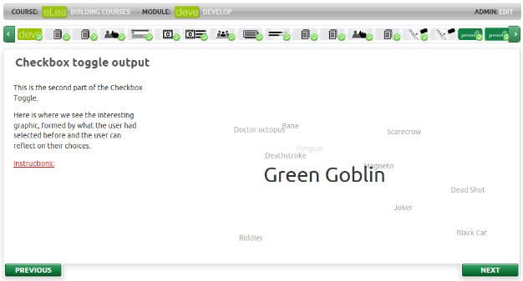
The checkbox playback panel will animate the selections of a user from a previously used checkbox toggle input screen.
These are good self-reflection tools.
A checkbox toggle can:
- Display the choices a learner previously gave to a checkbox toggle input screen
- Animate those choices

