Janison CLS

Functional Specifications

Document details

Version | Version 1
Last modified | 1 October 2013
Last Modified by | Greg McLoughlin-Wilden
Document status | Final
Approved by | Greg McLoughlin-Wilden
Approved Date | 1 October 2013
Owner | Canopi Online Pty Ltd
Documents location | /Canopi Clients/Canopi/Forms and Documents

Acceptance page for signing is located on the last page of this document

Revision history
Interim versions are permissible and are used to refine comments and input.

Date | Version | Modified By | Description
28/6/2012 | 1.0 | GMW | CLS Functional Specification
02/07/2015 | 1.0 | MBC | CLS Functional Specification
6/7/15 | 8 | Bron | Primarily formatting

Table of Contents

Overview 5
What is the Janison CLS? 5
What’s in this functional specification? 5
Key features 6
Key features of user management 6
Key features of learning management 6
Key features of learning design 6
Key features of system settings 7
User Management 8
User account management 8
External user account management 9
Organisations and organisation units 10
Hierarchies based on organisation structure 11
Approval and administration 11
Allocation of users to groups 12
Assign multiple roles to users 13
Assign learning to those roles and groups 14
Activity logging 15
Catalogue management 16
Auto assign courses on registration 17
Enrolment Methods 18
Payment methods 19
Moderated enrolments 20
Face to face learning 21
Manage competencies 22
Build catalogue Items 23
Mark test and assignments 24
Create customised reports 25
Expose reports to foreign systems 26
Tag resources 27
Create and manage tokens 28
Course management 29
Import SCORM courses 29
Design, edit and build courses 30
Design, edit and build modules 31
Design, edit and build independent tests 32
Design, edit and build embedded tests 33
Design, edit and build content templates 34
Add venues, presenters and classes for face to face 35
Manage Continuing Professional Development (CPD) 36
Manage System Settings 37
Modify the look and feel of the website 37
Modify the look and feel of the Catalogue page 38
Create custom attributes/sets 39
Custom pricing 40
Create and edit email templates 41
Create language profiles 42
Manage and grant RPL to learners 43
Create and manage content providers 44
Manage site authorisation 45
Edit form registration fields 46
Create custom workflows 47
Create and edit terms of use 48

Overview

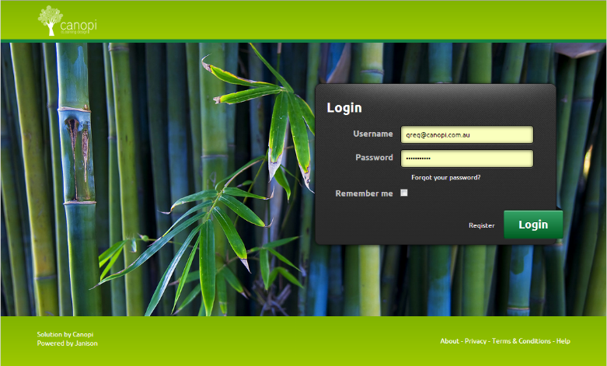
What is the Janison CLS?
The Janison CLS is the Learning Management System most often used by Canopi Online Pty Ltd.
It is built by an Australian Company, Janison Solutions Pty Ltd and made available through resellers or directly to clients.
The CLS is built using the latest Microsoft technologies, and can be hosted on their Australian web farm or in the Microsoft Azure cloud server.
Janison has won many industry awards for this software, and continues to develop the product with new builds being deployed every four weeks.
The architecture of the system relies heavily on plug in technology. What this means is that builds can be developed and deployed quickly with special features for one client that don’t affect other clients. This is rare in the software industry where new releases are often done once or twice a year.
From Canopi’s perspective one of the great advantages of the solution is that Janison own all the intellectual property (code base), meaning that they are entirely in control of the product.

What’s in this functional specification?
This functional specification outlines many of the key features of the platform to help you understand how those features work and what is possible.
Understanding the functions of the system is important because while the system is one of the most flexible in the market, it is rare that any system will perfectly match your business process. When there is a mismatch between the system processes and your businesses, then one of them will have to change to ensure a workable implementation of the system. While the settings in the system provide a wide range of options for configuring the process, you may still need to customise the system. One of the great capabilities of the Janison system is the ability to develop new functions within the system to match your business processes.
We have broken this specification into the following sections:
- Overview of features
- User and account management
- Enrolment management
- Learning management
- Site management

Key features
The Janison CLS allows for extremely fast and reliable development, delivery and management of learning.
The eLearning portal is hosted on the Janison server farm and offers clients the functionality of a Learning Management System - the management of users, courses and all learning activity.

Key features of user management
- Internal user account creation and management.
- External user account management though Single Sign On (SSO) models like Active Directory, LDAP, and SAML.
- Allocation of learners to organisations and organisation units.
- Build hierarchies of users to represent an organisation’s management and approval hierarchies.
- Allocation of users to groups for administrative purposes.
- Ability to assign multiple roles to users.
- Ability to assign workplace roles to users and then assign learning to those roles
- Full logging of user activity including login, logout, enrolment, learning, assessment and assessment attempts.

Key features of learning management
- Catalogue management - items in which people can enrol.
- Auto assignment of courses based on registration, roles, or group membership.
- Allowing enrolments based on PayPal, Credit Card payment, tokens or free access.
- Allowing enrolments to be moderated by an administrator or manager.
- Management of face to face learning or blended learning solutions.
- Assignment of competencies (vocational or workplace) based on catalogue completion.
- The build of catalogue items and completions from:
  - Online courses
  - Face to face courses
  - Assignments
  - Tests
  - Surveys
  - Trackable documents
  - Discussion forums
- Marking of submitted tests and assignments through the interface.
- Creation of customised reports based on all activity.
- Exposure of customised reports to external systems for periodic updates.
- Tagging of all resources for better searching.
- Creation and management of tokens for transferring the cost of a course from the enrolment - similar to an iTunes voucher.

Key features of learning design
The functionality to:
- Import SCORM courses.
- Design, build and edit courses within the system.
- Design, build, and edit modules to go within courses on the system.
- Design, build and edit tests within the system to be used as stand-alone exams.
- Design, build and edit tests within the system to be used within courses.
- Design, build and edit content templates within the system.
- Add venues, presenters, and classes for face to face workshops.
- Assign Continuing Professional Development (CPD) points to the completion of learning assets to manage CPD.

Key features of system settings
The functionality to:
- Modify the look and feel of the website.
- Modify the look and feel of the catalogue page.
- Edit all text and colours within the system.
- Select and configure different authentication methods for user accounts.
- Select and configure different credit card gateway settings.
- Create and assign custom attributes to user accounts, registration and enrolment so you can collect any information you want about a learning activity.
- Create custom pricing models for different user groups.
- Create and edit email templates to be sent to users upon event triggers like registration, enrolment and completion.
- Create language profiles for uses in different countries.
- Manage and assign Recognition of Prior Learning (RPL) to users.
- Create multiple providers of content within your system.
- Manage site authorisation via a public key that allows for public registration to your site, but requires a known ‘key’ to be entered before the registration is processed.
- Allow you to globally edit any term inside the site using editable string resources. For example ‘Not Completed’ can be changed globally to ‘Not Yet Competent’ in only one place, but will apply everywhere.
- Edit the fields for registration forms.
- Create custom workflows for the editing and creation of content and exams.
- Create and edit the ‘Terms of Use’ people must agree to before registration.

User Management

User account management
The CLS uses an internal account management system. A user’s account can have a number of default fields enabled and clients can enable different default fields in different contexts.
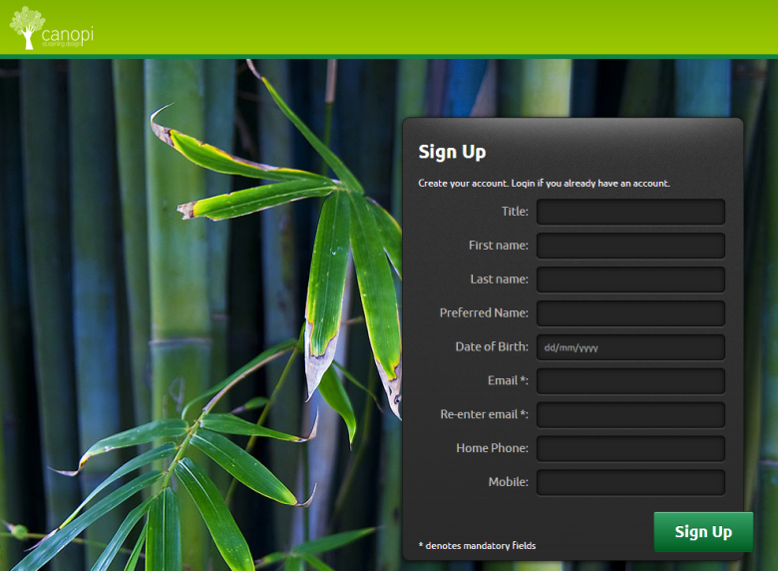
The default fields are:
- Title
- First name
- Middle name
- Last name
- Preferred name
- Student number
- Organisation
- Organisation unit
- Location
- Username
- Date of birth
- Gender
- Address line 1
- Address Line 2
- Suburb
- State
- Postcode
- Country
- Time zone
- Email
- Home phone
- Work phone
- Language
- Mobile

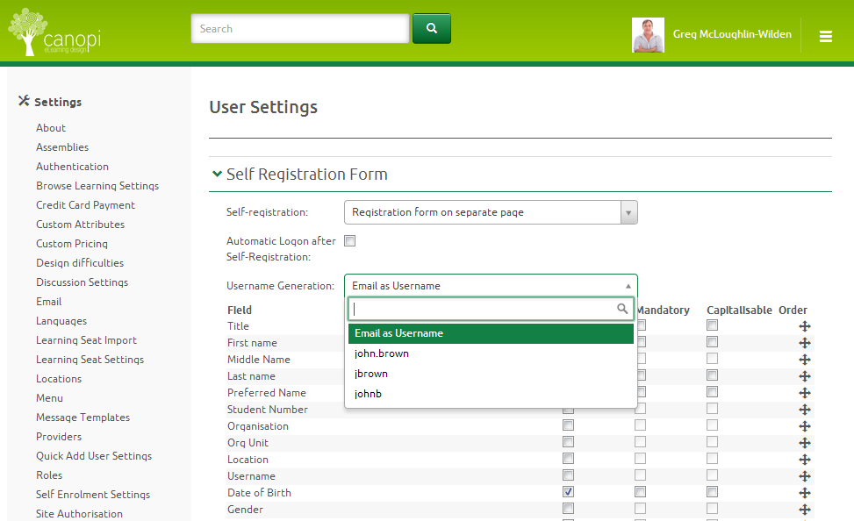
Each field can be made mandatory or optional and can be enabled/disabled in the following contexts:
- Registration
- Edit my profile
- List forms about users
- List user details
- Public Profile
Other options include:
- Fields can be renamed
- Fields can be re-ordered
- New fields can be added via custom attributes
- A default username format can be prescribed
- Sites can be forced to use the email as the username
- Capitalisation can be enabled/disabled (i.e. usernames are case sensitive)

External user account management

Protocols
The Janison CLS can manage external user accounts through a range of industry standard protocols.
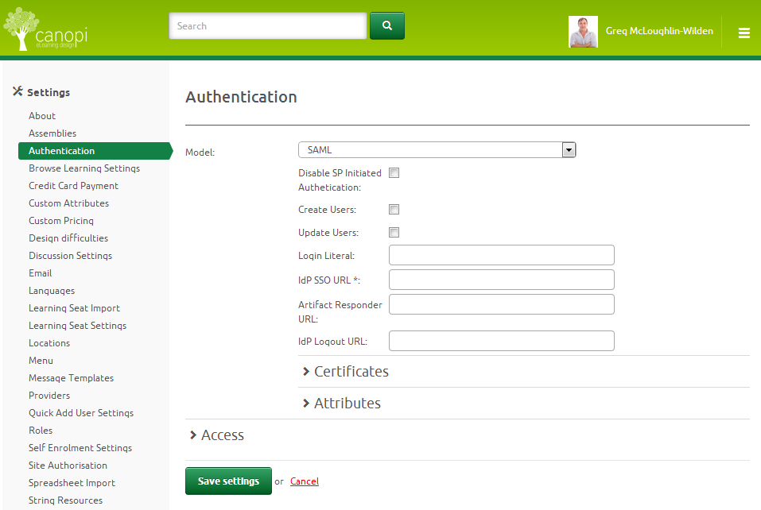
The three supported protocols in the system are:
- Active Directory
- LDAP
- SAML
Active Directory and LDAP are the preferred connection type for corporate networks, and SAML is commonly used for other web based systems.
All transactions between service providers can be configured for name translation, so that fields can be matched across systems.
The SAML protocol can support:
- Single Server Sign on models
- Authenticated data request
- Authenticated record injection including adding enrolment records
This makes it much simpler to integrate the learning system with your other systems.

Customised reports API
One of the unique features of the system is that whenever you make a customised report, you can publish it as an API. This means that if you create a report for the previous month’s completion and name it “MonthlyCompletions”, then the system will create a URL such as https://yourdomain/reportsapi/MonthlyCompletions.
If any authenticated system or user accesses that URL they will be parsed the results of the report as an XML data set. Filters can also be parsed to the API, so that you can just ask for completions in NSW, for example.

Organisations and organisation units
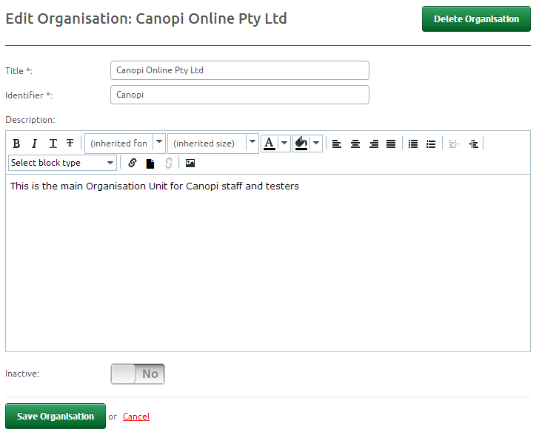
At the time of registration a learner can select or be assigned to an organisation and organisation unit.
This allows you to group learners by key stakeholders within your organisation.
For example, you may be a national organisation but want your state managers to view reports of only those people in their state.
At the time of registration or when editing a profile, a learner’s organisation and organisation unit can be edited at any time with no limits on the number of times it can be edited.

Key features
The functionality to:
- Group learners by organisations.
- Group learners by organisation units.
- Assign and update organisations and organisation unit structure from Activity Directory or SAML IdP each time the learner logs in.
- To import the organisation and organisation structure from Excel sheets.
- Have an unlimited number of organisations and organisation units.

Constraints
- A learner can only belong to one organisation and one organisation unit at a time
- A learner can only belong to an organisation unit if they belong to an organisation

Hierarchies based on organisation structure
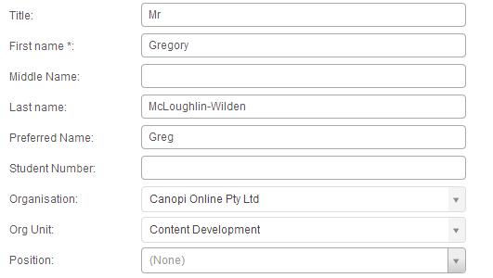
If you choose to build and maintain organisation hierarchies, externally or within the CLS, you can use these hierarchies to manage and approve learning.
The building of hierarchies is a twostep process.
- A learner is assigned to an organisation and organisation unit.
- Another user is given the role of Manager for that organisation and organisation unit.
In this manner a hierarchy is built that allows the manager to view, assign and approve learning for people in their organisation unit.
A person who has been made a Manager for an Organisation would be able to view, assign and approve learning for everybody in that Organisation.
These Hierarchies can be passed over from Active Directory or imported regularly to maintain the Hierarchy.

Key features
- Users can belong to organisations and organisation units
- Users can be made managers of organisations and organisation units
- Managers can view, assign and approve learning for users in their hierarchy
- Users can hold positions within an organisation unit

Constraints
Users can only belong to one Organisation and organisation unit. However, this constraint can be overcome by using groups as another permissions structure

Approval and administration
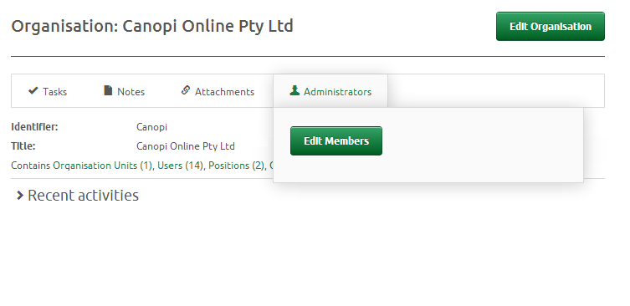
Within the eLearning portal you can establish approval and administration roles and assign them to different areas of the application. This capability can be used in a number of ways but most commonly, you can allow managers to approve and monitor the progress of learners within their part of the Organisation.
For example, a NSW Manager can assign, approve and report on peoples’ learning activities if they’ve been granted those permissions.
Equally as powerful is the ability to assign these permissions to groups as well. So within the same national structure, you might have the national WHS person who needs to assign, approve and report on each sites’ WHS skills. They can be assigned permissions at the national level, but only to the Group WHS.

Key Features
- Approval of training can be assigned from a Hierarchy within the application.
- The Hierarchy can be propagated from Active Directory or a SAML based IdP.
- Permissions can be granted based on:
  - Organisations
  - Organisation Units
  - Roles
  - Groups
- Training enrolment rules can be set to ‘Approve by Admin’, or ‘Approve by Admin and Manager’

Allocation of users to groups
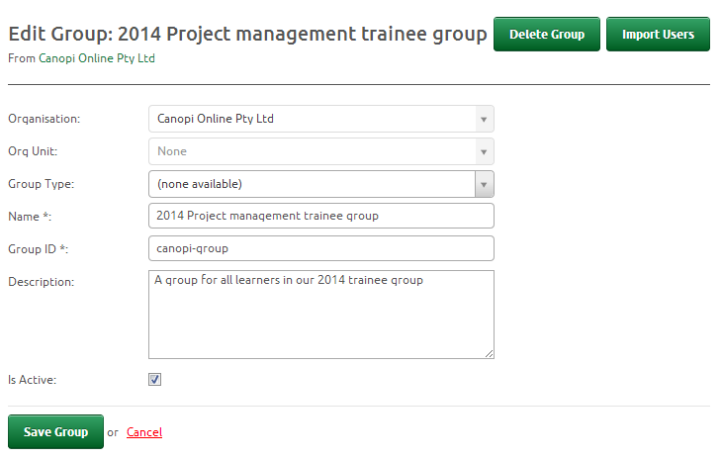
Within the system you can create an infinite number of groups to collect learning activity together, or to create common interest groups around job tasks.
The two most common applications of the ‘Group’ feature are:
- To create a class of student in a school context so that a teacher can be assigned to that class and review, for example “Class 10 Red 2014”.
- To create a collection of people working towards or through a common education process, for example “2014 project manager trainees”.
If you use the token enrolment method on your site then you can auto assign someone to a group when they use the token.

Key Features
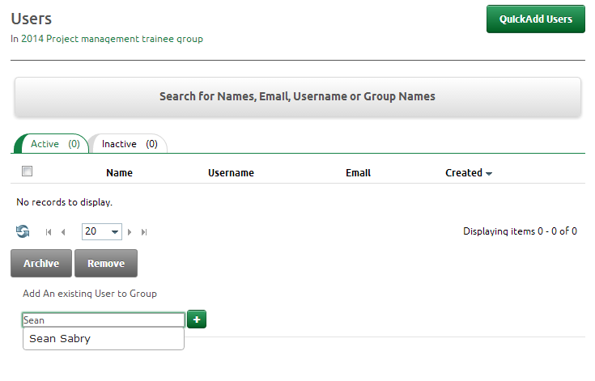
- Infinite number of groups can be created.
- Groups can have selected types.
- Groups can be made inactive.
- Learners can be assigned to groups.
- Administrators (teachers) can be assigned to groups.
- Users can be assigned to more than one group.

Constraints
- People must belong to the same Organisation and Organisation Unit as the group to be assigned to it

Assign multiple roles to users
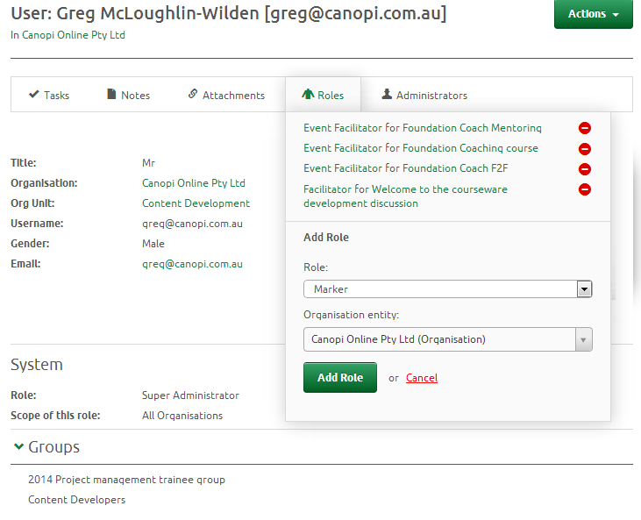
A user within the system can have many roles and belong to many groups. For example, they may be a learner in one group, an administrator of several groups and a marker for a third group of learners.
This ability to assign a person many roles within the system reflects the common topography of the school or workplace where a person will commonly have many duties within the Organisation.

Key features
- A user can be assigned many roles within the system.
- New roles can be created beyond the 16 standard roles in the system.
- Roles can be given different permissions over areas of the application, right down to the button level. You can remove actions on buttons down to the role level.

Default Roles
- Basic User
- Chief Marker
- Content Administrator
- Content Approver
- Content Designer
- Content Quality Assurer
- Content Reviewer
- Event Facilitator
- Guest User
- Marker
- Organisation Administrator
- Super Administrator
- Surveyor
- Tenant Administrator
- User Manager
- User Record Owner
Other roles can be created and assigned permissions within the application. Creating roles can be done by the Administrator for the portal but we suggest that this be completed by Janison, as it is a complicated task, and can cause major issues within the portal if not done correctly.

Assign learning to those roles and groups
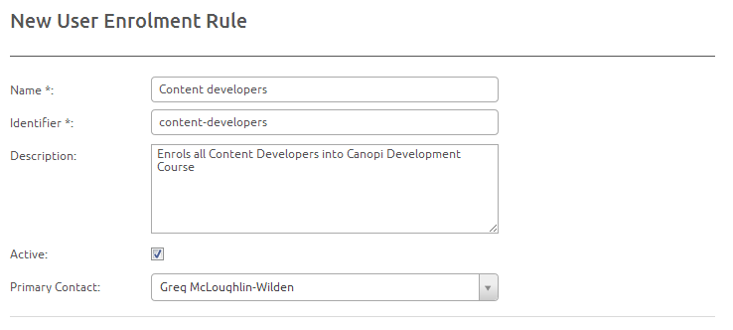
Using the powerful Rules system within the portal you can create a range of different ‘Rules’ to define the behaviour of the website.
One of the most common uses of this is to auto assign courses to people when events like Registration, Role membership, or group membership happens.
For example, when somebody registers on your portal as a basic user, you might auto assign them to a course on ‘eLearning Survival Skills’.
Similarly, when you make somebody a ‘Marker’ you might automatically assign them a course on ‘How to Mark exams’.
Rules can be run on a number of events including:
- Registration
- Enrolment
- Group membership
- Role membership
- Organisation membership
- Organisation Unit membership

Key Features
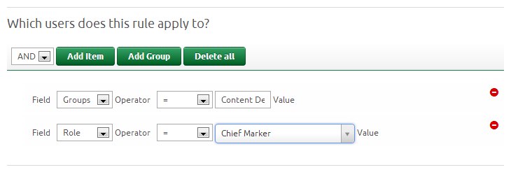
- Infinite number of rules can be created.
- A contact person can be assigned to each rule.
- The enrolment can be given expiry dates and due dates.
- The rule can apply to multiple criteria.
- Can be scheduled to run on Registration or as part of a daily batch.
- Rules can be ‘Test run’ to see their effects on enrolments.

Activity logging
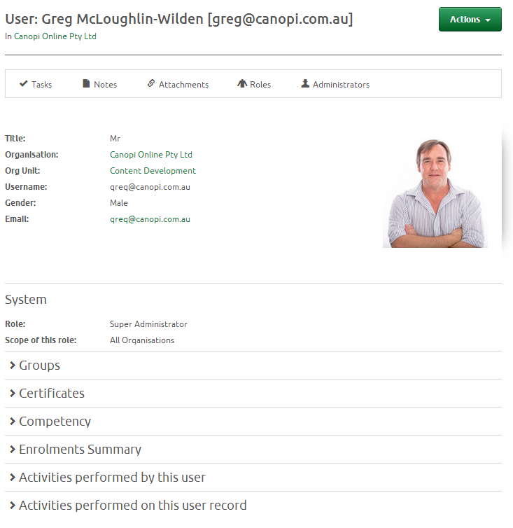
Every action in the system is logged and linked to the user account.
Everything from registration, enrolment, completion, editing of roles, groups and courseware is recorded by the system.
The logs are broken into two sections:
- Actions performed by the User
- Actions performed on the User
This way of splitting up the logs makes it easier to view and administer the learner.
The logging makes it especially easy to provide support to users over the phone. You can literally watch them register, enrol and start their learning as you talk them through it.

Key features
Some of the key logs are:
- User Registrations are logged
- User logins are logged
- User logouts are logged
- User enrolments are logged
- Course openings are logged
- Test submissions are logged
- Module and course completions are logged
- Exam completions are logged
- Content editing is logged

Constraints
- At this stage there are no constraints on logging. However as the databases grow on your site, logs may be limited to periods like 1 – 2 years.

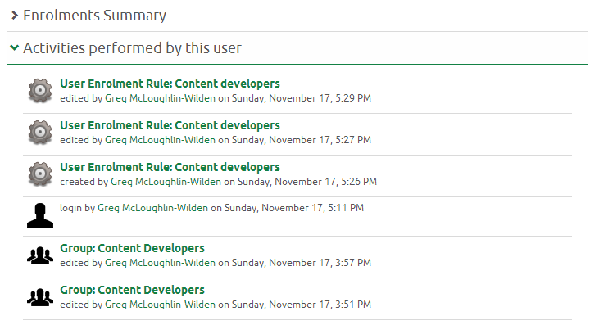
In addition to the key features, most log entries have hyperlinks to take the user or someone looking at the user back to what the person was doing. This is especially helpful if, for example, you know that a user edited a group six months ago. You can search the user record and see what they were working on in relation to the entry.

Catalogue management
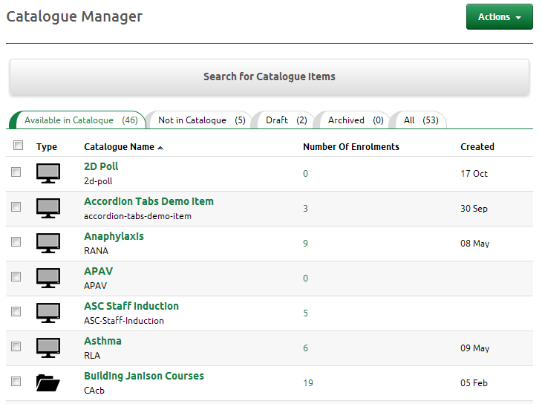
The Catalogue system creates a list of learning activities that a user can enrol in, or be assigned to.
Most commonly, the Catalogue items are visible in the ‘Browse Learning’ Tab and can contain the following learning assets:
- System built online courses
- Imported SCORM online courses
- Exams
- Face to face workshops
- Trackable documents
- Discussion forums
- Surveys
- Assessment events
A Catalogue item may contain any combination of the above. Importantly Catalogue items can contain more than one learning asset.

Key Features
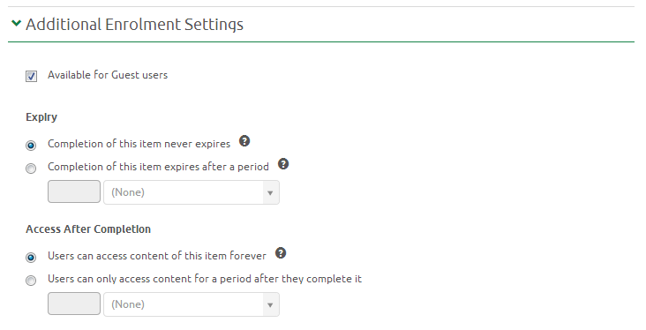
- Create and edit the name of the Catalogue item.
- Create and edit the identifier of the Catalogue item.
- Select a provider of the item.
- Create and edit the author of the item.
- Provide a description for the item that is displayed to learners before they enrol.
- Provide the learning objectives of the item.
- Set a price for the item.
- Set a due date.
- Provide a small and large thumbnail.
- Define a certificate to be used.
- Select all the components that will be in the catalogue item.
- Attach any relevant competencies to the item.
- Select a template for displaying more than one learning asset in the Catalogue.
- Set the enrolment options: free, token, credit card or moderated.
- Set the re-enrolment options.
- State if the course is available to guest users.
- Set course ‘expiry’ if required i.e. the currency has a life of three years.
- Define if the learner can access the course after they complete and, if so, for how long.

Constraints
- You cannot add/remove learning assets if you have incomplete learners without recalculating the completion rules.
- You cannot remove an exam from the learning assets if it has attempts in progress.

Auto assign courses on registration
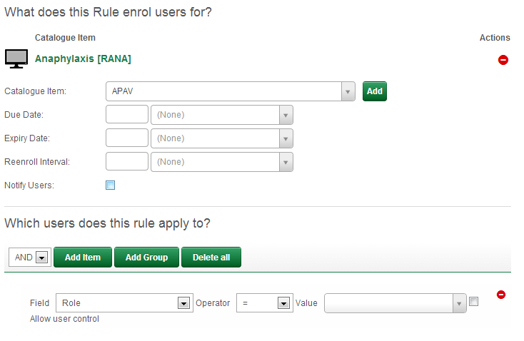
The CLS has the functionality to create rules for enrolment. These rules can be run on certain events in the system like registration, or based on membership to organisation units or roles with the organisation.
There is no limit to the number of rules you can build and run.
Some common uses for rules are:
- Auto assigning a ‘Welcome’ course for new learners.
- Enrolling someone in a compliance course if they join a work group.
- Enrolling someone in a Safety Course if they work in certain state.

Key features
- Rules have names, identifiers, descriptions, and can be made active or inactive.
- Can enrol a person in more than one catalogue item.
- Can have a due date, expiry date and re-enrol date set.
- Multiple triggers for the one rule, such as;
  - Organisation
  - Organisation unit
  - Date of birth
  - Group members
  - Roles
  - Managers name
- Rules can be run daily or at registration.
- A test run can be performed to show who will be affected by it.

Enrolment Methods
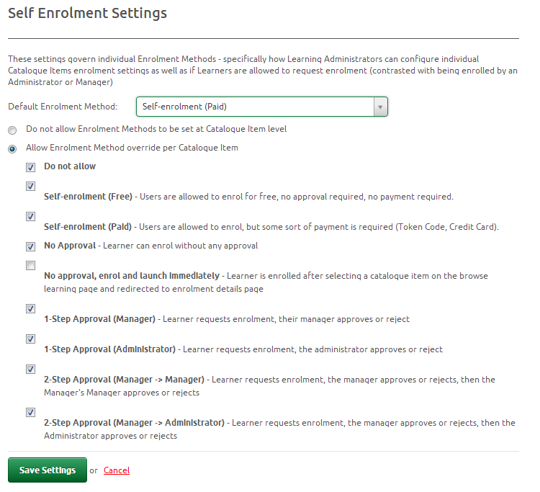
The system can support a range of different enrolment methods.
This gives flexibility in how Organisations manage the enrolment of users in courses.
The enrolment methods include:
- Not allowed (must be assigned)
- Free enrolment
- Credit card/PayPal payment
- Manager approval
- Manager > Manager approval
- Administrator approval
- Manager > Admin approval
- Enrol and launch direct
The display of items in the catalogue can be configured using templates within the system. The default template provides a clean list of items in the catalogue that can be:
- Searched
- Ranked
- Reviewed
- Email as a ‘Recommended’ link
- Display a price
- Have discussion linked to them

Key Features
- A range of different enrolment methods available
- Can be set as a global setting for the portal with no override
- Can be set as a default at the global level but then overridden when creating/editing a catalogue item

Constraints
- One catalogue item can only have one enrolment method. This can be managed by having two instances of a course in the catalogue. For example, one free for Australian residents, and one that requires payment for offshore learners.
- A credit card payment option can only be configured if you have an eCommerce gateway configured.

Payment methods
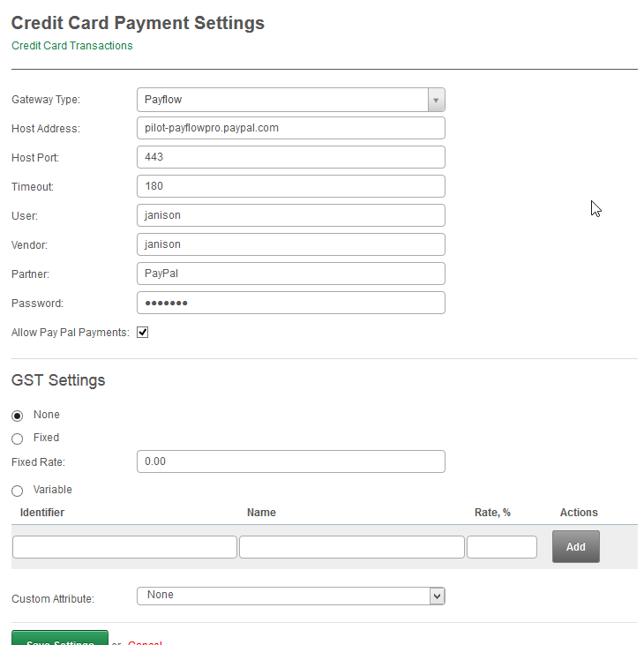
The eLearning system supports a number of eCommerce gateways for the processing of payments online.
The supported gateways include:
- Comm Web
- SecurePay
- E-Xact Transactions
- PayPal PayFlow
- Ogone
- Paypal
- IP payments
- First Data
- PIN Payments
Other gateways can be developed at the client’s cost.

Key Features
The credit card payment facility has the following features:
- Ability to configure the merchant details.
- Can have different prices on each catalogue item.
- Ability to set a GST rate on the site for course payment.
- A confirmation email reflecting GST invoice can be sent to the learner.
- Custom information (fields) can be gathered at the time of payment.

Configuration for PayPal PayFlow
The information required to configure eCommerce payments via PayPal is:
- Host address (already known)
- Host Port (already known)
- Timeout (already known)
- User (to be provided by client)
- Vendor (already known)
- Partner (already known)
- Password (to be provided by client)

Constraints
- Only one payment gateway can be configured per portal

Process
- The learner chooses the catalogue item.
- The learner clicks the ‘Enrol’ button.
- The user enters their credit card details.
- The payment is confirmed on the learning site.
- An email is sent to the learner, which can be modified to be a receipt.
- An email can be sent to an administrator advising them of payment.
- The learner is returned to the ‘My Learning’ Page and they can commence the course.

Moderated enrolments
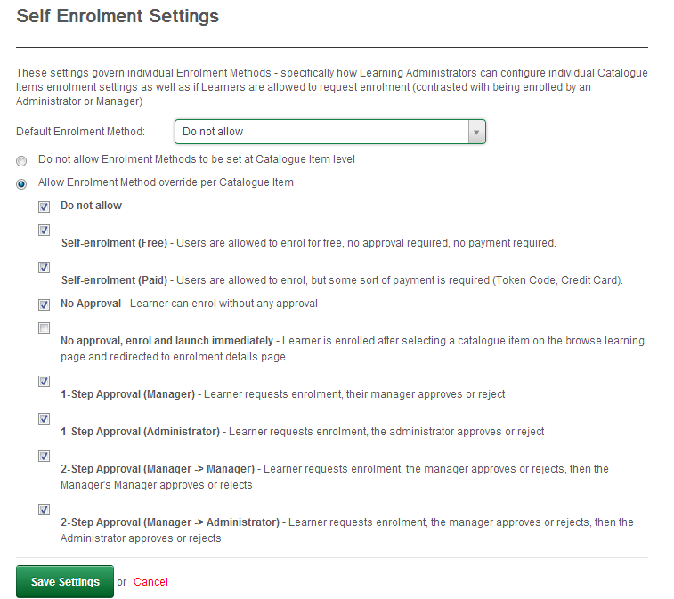
An enrolment in a course can be moderated by a person’s manager or the system administrator.
For a number of reasons you may like to offer courses for free but moderate or check if a person should do a course. This is especially useful if the organisation has to pay for the enrolment. You don’t want a hundred people just enrolling in a course without some way to control the expenditure.
Moderated enrolments are managed as part of the self-enrolment settings in the administrator’s panel.

Key Features
- Self-enrolments can be set at the tenant level or individually on each catalogue item.
- Self-enrolments can be disabled, free or paid.
- No approval required and the course launched immediately.
- Manager approval required.
- Administrator approval required.
- Manager, then their manager must approve the enrolment.
- Manager and then administrator must approve the enrolment.

Constraints
- Only one manager and admin approval method can be selected at a time.

Face to face learning
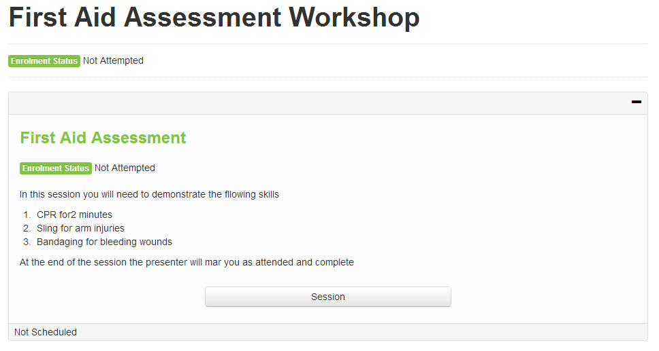
Beyond eLearning, the system can manage face to face sessions either as unique catalogue items or as ‘Learning Assets’ that must be completed as part of an online course.
This creates a powerful way to manage blended learning solutions within your organisation.
- Face to face courses can be managed.
- A learning event is created and then sessions can be created for each one. For example, if your organisation runs a First Aid assessment session, you would create an event called ‘First Aid Assessment’ and then create a session in each state that people can search and attend.
- A learner expresses interest in a session which is then confirmed by the facilitator. A facilitator can then run the session and mark attendees as not-present, present but incomplete, or present and complete.

Key features
- Events (courses) can be created
- Sessions can be added to events
- Sessions can be assigned venues and facilitators
- Venues can have addresses and use google maps to show the location
- Manage face to face learning and classes
- Assign competencies (vocational or workplace) based on catalogue completion
- Build catalogue items and completions from
  - Online courses
  - Face to face courses
  - Assignments
  - Tests
  - Surveys
  - Trackable documents
  - Discussion forums
- Mark submitted tests and assignments through the interface
- Create customised reports based on all activity
- Expose customised reports to external systems for periodic updates
- Tag all resources for better searching
- Create and manage tokens for transferring the cost of a course from the enrolment. Similar to an ITunes voucher

Manage competencies
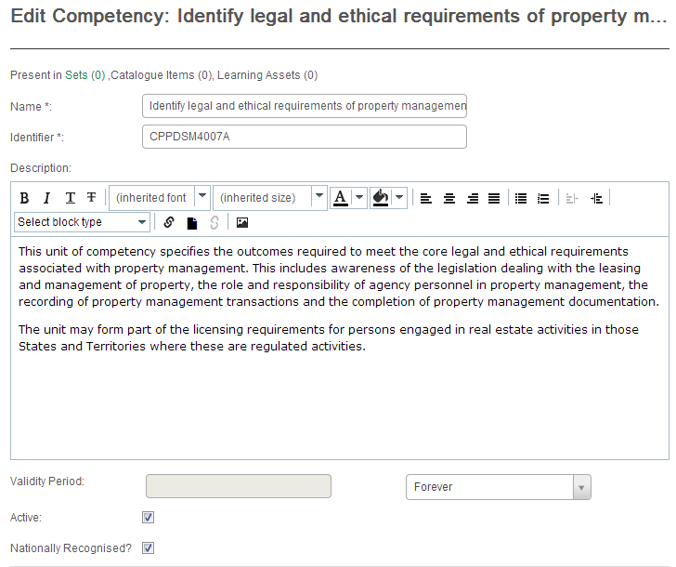
Competencies can be either accredited Units of Competency under the Australian Qualification Training Framework (AQTF), or specific skill set that is required in a workplace.
Each catalogue item can be assigned single or multiple competencies or a competency group which might represent a skills set under the AQTF.
When the learner successfully completes the catalogue item they will be granted the competency/s or competency set.
Reports can be run within the system to determine if people have the required competencies to do their work, or exported for use in another system.

Key Features
- Can be assigned to catalogue items
- Are allowed to have a ‘Competency life’ so that they expire after a given time
- Single competencies can be grouped into skill sets or qualifications
- Learners can be given Recognition of Prior Learning (RPL) against competencies

Constraints
- At this stage there are no packaging rules of core and elective units to determine the completion of a qualification. This is in the product roadmap.

Build catalogue Items
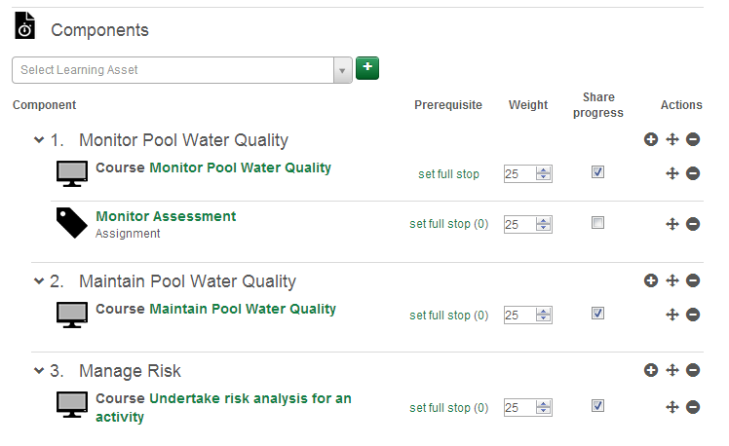
A Catalogue item is the object that a learner enrols in. Catalogues themselves can have the following information.
- A title
- An identifier
- Tags for searching
- A description
- Large thumbnail
- Small thumbnail
- Price, due date and a certificate
- An enrolment method
- Re-enrolment settings
When building a catalogue item you can add ‘Learning Assets’ to them. These assets can include:
- Online courses
- Face to face courses
- Assignments
- Exams/tests
- Surveys
- Trackable documents
- Discussion forums
- Assignments

Key Features
- A learning asset can be used in multiple catalogue items.
- If a learner completes a learning asset in one catalogue item they can be given credit for it in another catalogue item.

Constraints
- Each catalogue item can only have one price (or be free).
- Each catalogue item can only have one enrolment method. You might have two catalogue items to allow price discrimination in different markets.

Mark test and assignments
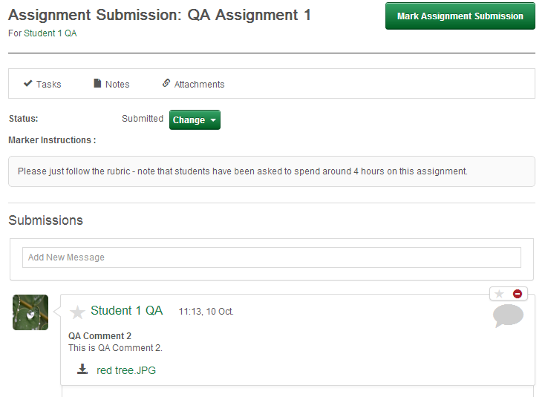
Two of the learning assets that can be included in the Catalogue Item area are assignments and tests. These items can be set to be scored by ‘Markers’ and put in a queue for them to review and provide feedback.
Assignments can enter a workflow, where the marker might not initially pass the learner and ask for more information. The system facilitates feedback from the marker to the learner and in the assignment mode, learners can upload more than one file as part of their submission.

Key Features
- Items to be marked are placed in a queue.
- Questions can have marking rubrics to assist markers with model answers.
- Feedback can be given to the learners.
- Assignments can be set to allow single or multiple submissions.
- Assignments allow for learners to upload documents, pictures, video and sound files for submission.

Create customised reports
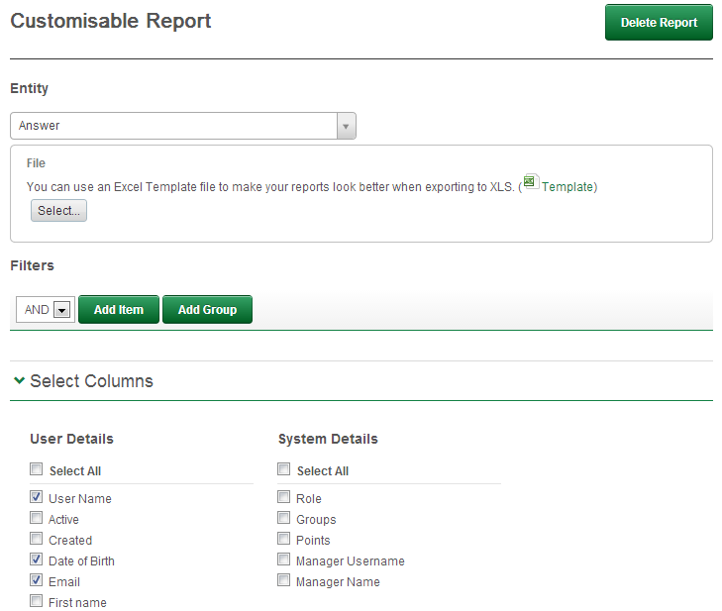
Customised reports allow administrators to create and save reports within the systems. These reports can be saved, emailed, or sent to a file server for later use.
You can select fields from certain ‘entities’ or areas of the applications for use in the reports. These entities include:
- Answers
- Answers scores
- Assignment submissions
- Catalogue items
- Learning asset links
- Competency unit status
- Credit card transactions
- Discussion forums
- Enrolments
- Enrolment by token orders
- Learning event session attendance
- Logins sessions
- Other learning
- Progress
- Progress courses
- Progress trackable documents
- Test attempts
- Users

Key Features
- Choose from over 2,000 fields in over 20 entities for your reports
- Schedule reports to be emailed
- Schedule reports to be saved to files
- Export reports to XLS, CSV, or PDF files
- Create templates to be used by reports for summary and layout options
- Apply multiple filters to data

Constraints
- Cross tab queries are not currently possible, but can be created in the Excel templates.

Expose reports to foreign systems
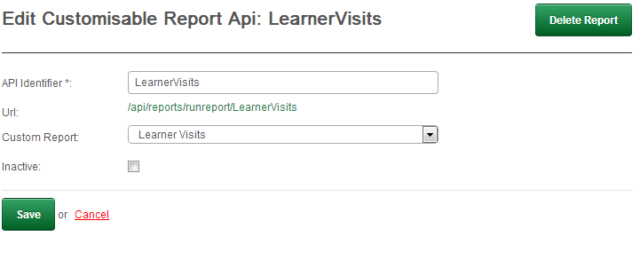
Any customisable report can be made visible to foreign systems. These systems could ask for a daily update of enrolments for example, and import the data as XML.
This functionality is an easy way to connect two systems together using Application Programming Interfaces (API).
The requests are embedded within the security system and can be accessed via the SAML security model or the HMAC messaging security model.

Key features
- Any customised report can be exposed through a report API
- Each report is given a unique URL
- The API can be queried to expose all fields available for filtering
- Filters can be passed to the report API
- User access can be granted through SAML
- Server access can be granted through HMAC
- Report API can be disabled

Tag resources
The CLS has a powerful searching system that allows many resources within the system to be ‘tagged’. Tagging an item allows administrators and developers to assign multiple pieces of meta-data to any resource.
This meta data can be used to build queries, assign items to catalogues or questions to exams for example.
In exams for example, a developer could create a test and use 40 questions from a bank of 100, and only use questions that are tagged with ‘Section1’.

Key features
- Items that can be tagged include but are not limited to:
  - Catalogue items
  - Courses
  - Modules
  - Exams
  - Questions
  - Resources like video, images, and documents

Create and manage tokens
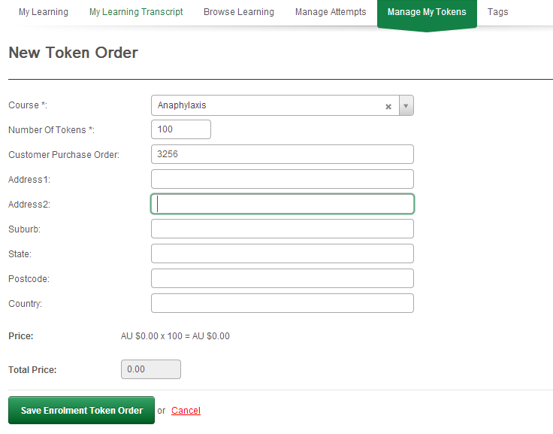
Tokens are a great way to separate the cost of doing a course from the learner to somebody else like an employer.
A token is an eight digit code and works much like an iTunes voucher. A person can order a set of tokens and assign them to a group like ‘Class 9G’ and then review the activities of learners in that group.
Tokens are linked to catalogue items and when configured on the system, a new enrolment method is displayed to the learner. When they select ‘Enrol’, they will be asked for their token code. Once validated they will be enrolled in the course.
A person requesting tokens is called a ‘buyer’. A buyer can review their full history of orders and click to review the progress of learners in the orders they have placed previously.

Key features
- Token orders can be enabled or disabled at the catalogue level of access.
- Custom attributes can be assigned to the token order to collect any other information you require at the time of ordering.
- The administrator can review a list of token requests, and approve them (normally after issuing an invoice to the buyer).
- When approved the buyer is emailed an advice letter and provided with all of the token codes they requested.

Constraints
- One token code is only valid for one course

Course management

Import SCORM courses
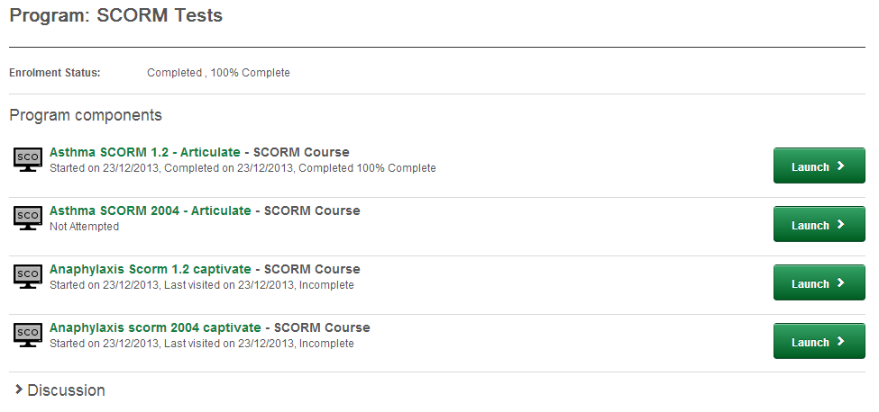
The CLS will allow for the importation of courses built to the SCORM standard.
Popular desktop content authoring packages like Captivate™ and Articulate™ can export their courses in the industry content packaging standard called SCORM. The two common standards or versions in use are:
- SCORM 1.2
- SCORM 2004
Old as they are, the very first versions of SCORM are still very popular standards and still in common use.
The Janison CLS supports both of these SCORM standards and development is in progress on the draft ‘Tin Can’ standards being ratified as at 2014.

Key features
- Allows for importing SCORM packages of all three common SCORM standards
- The SCORM API allows for exchange of the course results data
- The API allows for exchange of the basic ‘Suspend Data’ as per the standard.
  - 4096 characters for SCORM 1.2
  - 4000 characters for SCORM 2004 3nd edition
- There is extended support for 64,000 characters in the suspend data as per the SCORM 2004 3rd edition standard but clients are advised to run their own testing of this execution as not all authoring packages readily support this larger amount of data exchange.

Constraints
- The only known constraint with SCORM is the exchange of large amounts of suspend data. The Janison CLS can manage this fine, but we still find problems with this through either the content authoring package not managing it very well, or more commonly if the learner’s connection is slow then the suspend data can get lost when being sent back to the system.
- The only resolution to this is to send the data back more often (like at the completion of each page). This makes it more reliable, but slows the learner’s connection down significantly as you are sending large amounts of data more often.

Design, edit and build courses
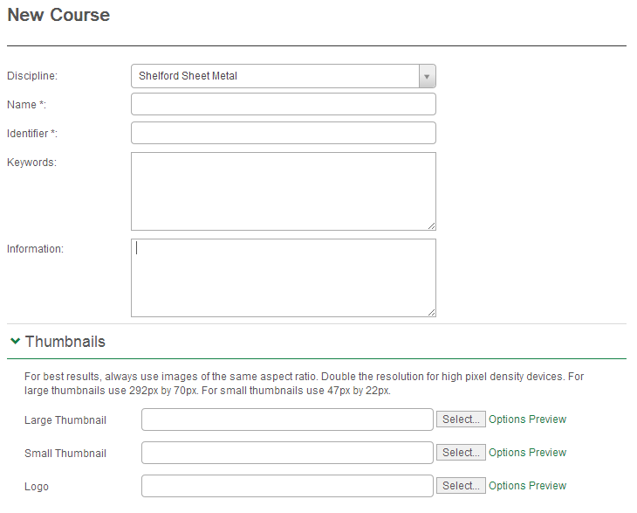
In the Janison CLS, online courses are made up of modules. The modules contain the pages and the learning as well as tests and interactions. The terminology of courses and modules can be changed within the system through the language dictionary, so if you prefer the terminology of say ‘sections’ and modules you can reset these globally within the site.
A Janison course contains just the online learning component. Other assets such as exams, surveys and discussion forums can be contained in the catalogue item.

Key features
- Courses belong to disciplines
- Support unique identifiers
- Have descriptions (HTML can be embedded within the description)
- Modules that can be ordered as required
- Competencies

Constraints
- Only modules from the same Discipline as the course can be included in the course.

Design, edit and build modules
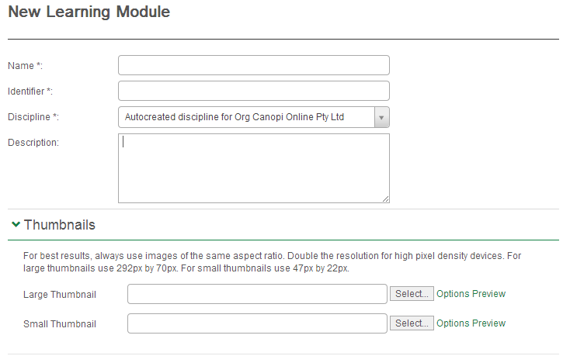
Modules are the core foundation of the learning environment and are a re-usable chunk of learning. Modules contains the pages for the learning and can be re-used at a number of levels.
When creating a module you have four choices:
- Add an assessment module
- Add a learning module
- Add a custom pages module
- Import a module (Janison modules)
An assessment module is used in the exam system to present tests to the learners.
A learning module is the most common type of module used. These have the following attributes:
- Name
- Unique identifier
- Disciplines
- Description
- Pages
- Have small and large thumbnails
A module will generally relate to about 20 -30 minutes of learning. The name for these can be changed to ‘topics’ within the system.

Key features
- Modules are units or topics of learning
- They generally relate to a block of learning time
- Modules are built up into courses
- Have thumbnails for ease of navigation
- Modules can exist in more than one course

Constraints
- A module can only be used in a course of the same discipline

Design, edit and build independent tests
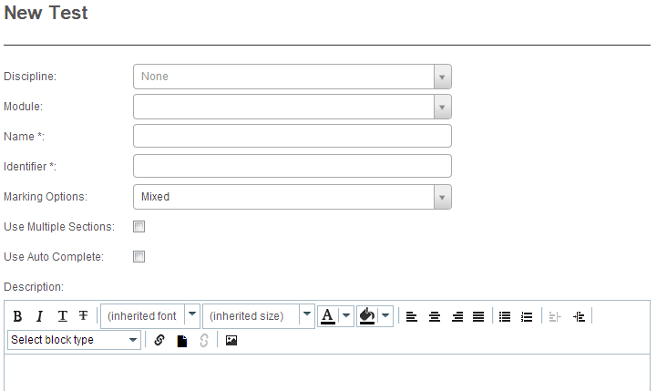
Tests are another often used asset within the CLS. They can be built up into catalogue items so that one saleable item can have more than one test in it.
The test system within the CLS is a robust, high security part of the application. A test in the system can be computer marked, assessor marked, or a combination of both.
Test can contain the following types of questions:
- Multiple choice
- Multiple choices
- True/false
- Flip tiles
- Match
- Cloze
- Ordered sequence
- Drag and drop
- Short answer
- File upload
It is important to note that these are the question types supported in the test player, not in the micro quiz system used within courses.

Key features
- Tests are re-usable in more than one catalogue item
- Can be computer, person or mixed marked
- Can contain sections
- Have randomised question banks
- Have randomised order of questions
- Have randomised order of distractors
- Be timed
- Have set pass marks
- Have competencies assigned to them

Constraints
- Not all of the same question types are supported in the micro quiz as in the test player.

Design, edit and build embedded tests
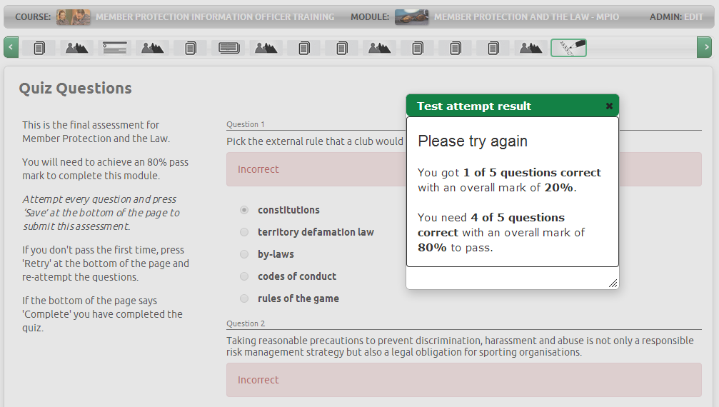
Tests can also be created and embedded within courses using the micro quiz panel type. These tests have fewer supported question types but allow the instructional designer to develop feedback for each test to help guide and correct the learning.
Each test and question can have its own feedback and different pass marks can be set for each test. This means you can set a pass mark of 0 if you just want the learner to check in on their learning but not be held up by having to get the right answer. In a more summative assessment model, you can set higher pass marks like 80 or 100 percent and force the learner to get the right answer before progressing.

Key features
- Supported question types include
  - Multiple choice
  - Multiple choices
  - True/false
  - Flip tile
  - Single word or phrase (Cloze)
- Attempts can be saved so the learner can go back and review content before coming back to complete the test with their previous saved answers.
- Administrators and markers can review all test attempts.
- Feedback at the test or question level.
- Multiple attempts allowed.
- Page won’t complete until test is passed.

Constraints
- Not all questions types from independent tests are supported.
- Cannot set a limit on the number of attempts a learner can have.

Design, edit and build content templates
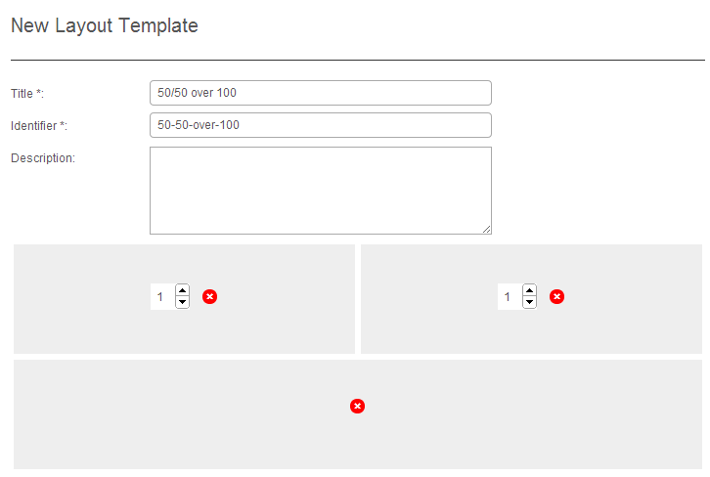
The CLS has a number of templates for laying out the content on a page of learning.
If there is not a template in the default installation that suits your learning, you can build a custom content layout template to specifically control how the content appears on the page.
There is either a graphical or script based interface for editing the templates so you can have very precise control over the layout, colour and shadow styles of the template.

Key features
The key features of the layout template designer are:
- Add content areas to the page
- Add custom scripts for that content template
- Add custom CSS styles to that content template
- Add custom HTML elements to the layout

Constraints
- You cannot edit global templates in the system (the default ones)

Add venues, presenters and classes for face to face
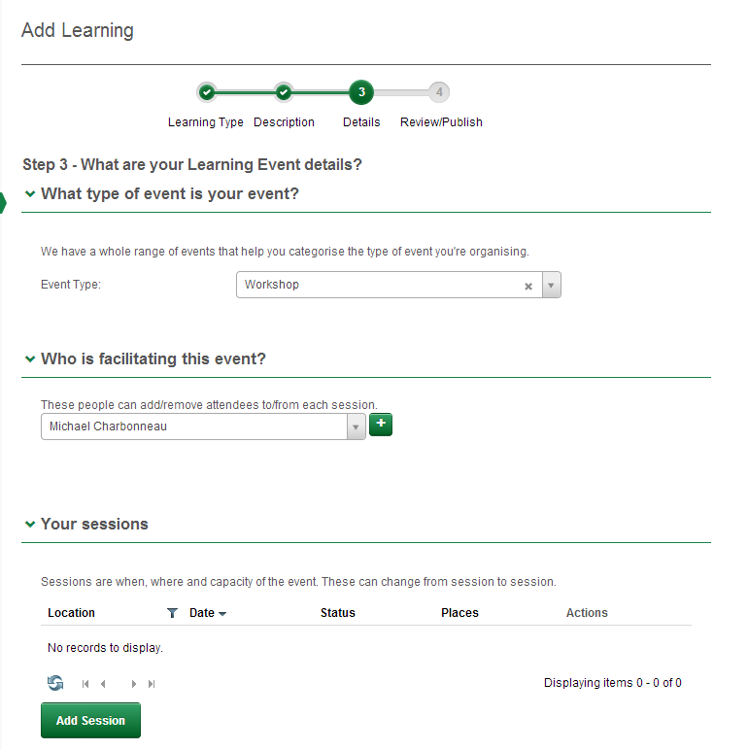
The Janison CLS can manage face to face learning events like workshops, presentations, classes and assessment sessions.
A learning event has details assigned that allow for the easy management of the event and for learners to search and enrol in them.
Default learning event types include:
- Face to face
- Conference
- Informal session
- Lecture
- Mentoring
- Webinar
- Workshops
Other learning event types can be created by administrators as required.

Key features:
The key features of these events are:
- The type of event
- The facilitator’s details
- The session details
- Multiple sessions per learning event
- Sessions have venues associated with them

Manage Continuing Professional Development (CPD)
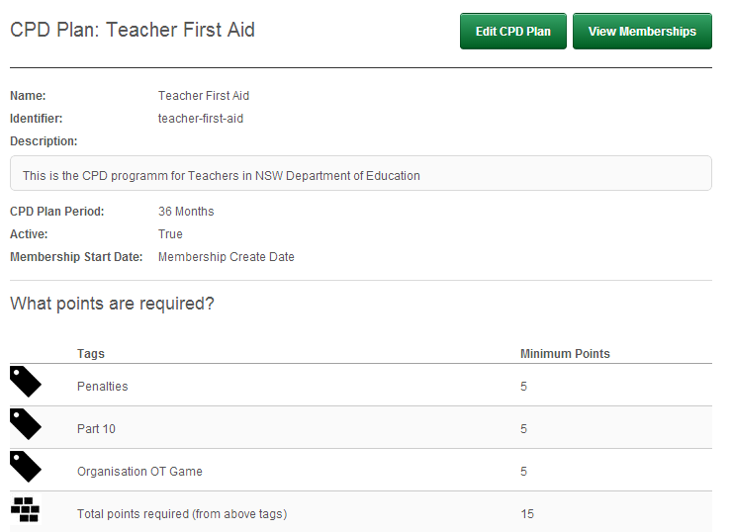
CPD is a key component of many workplaces. It requires staff/learners to complete a certain amount of learning activity within a given time frame to maintain certification currency.
An example may be a teacher who has to do First Aid every three years and Resuscitation once a year.
The CLS can manage the skilling and reporting requirements associated with these rules to allow staff to plan for the professional development, and for managers to report and budget the resources to ensure it happens.

Key features
- Any number of plans can be created and assigned to roles, groups or individuals
- CPD points can be assigned to learning within the system including face to face events
- CPD can be assigned and granted to learners for external activities
- Learners can view their progress towards their CPD requirements
- Managers and administrators can view the organisations compliance views and filter the reports by Users, Organisations, Organisational units or Groups.

Manage System Settings
The system settings on the CLS appear in separate menu items for administrators and allow for the configuration and setup of a tenant.

Modify the look and feel of the website
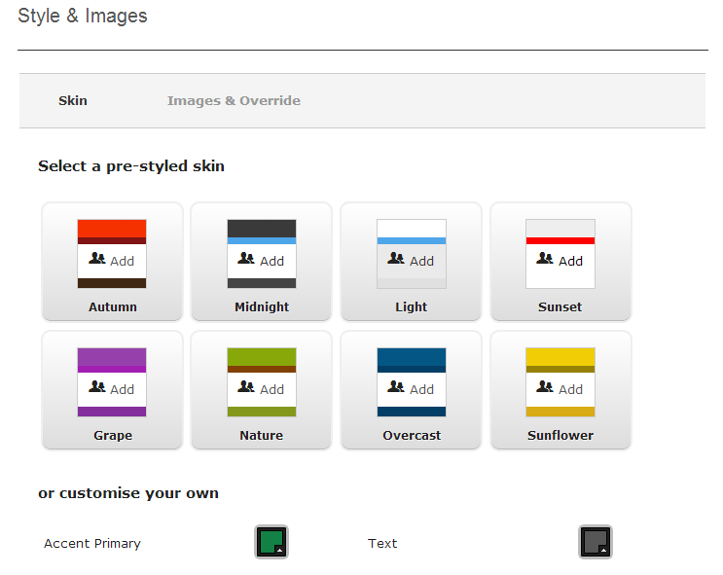
The look and feel of any CLS portal can be configured on the fly by the tenant administrator.
The primary options for this are the colours and the images on the portal. There are eight preset colour themes that can be selected and then modified to match any corporate branding.
The default themes are:
- Autumn
- Midnight
- Light
- Sunset
- Grape
- Nature
- Overcast
- Sunflower
The colour regions of the system that can be edited are:
- Accent primary
- Accent text
- Background primary
- Background secondary
- Header top
- Header bottom
- Header text
- Text
- Footer top
- Footer bottom
- Footer text
- Border primary
- Border secondary
The images that can be edited on the portal are:
- Logo
- Printable logo
- Login image
- Favicon

Any custom CSS required on the site, such as changes to fonts, can be accomplished in these settings using a custom CSS style sheet.

Modify the look and feel of the Catalogue page
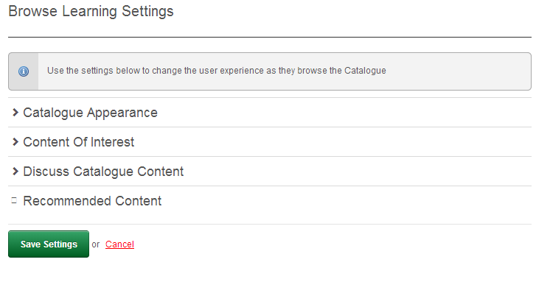
When a learner clicks the ‘Browse Learning’ link to enrol in new courses, there are many options that can be set to change the way that information is presented.
These options include:
- The appearance of the Catalogue
- Showing the learning content of interest
- Showing discussion forums
- Recommending content

Key features:
The key features of the Catalogue appearance are:
- Allow searching by price, language, and learning type
- Allow sorting by title, popularity, comments and latest
- Set a default sorting criteria
- Show filters for price, rating and comments
- Enable a left hand filter menu
- Develop a custom menu for search navigation
The key features of the ‘Content of Interest’ are:
- Enable or disable content of interest
- Select tags for showing catalogue items in the content of interest
- Set a welcome message before showing content of interest
The key features of the ‘Discuss Catalogue item’ are:
- Enable or disable Content discussion
- Allow comments based on started or completed status
- Enable or disable a star rating system on catalogue items
The key features of the recommend content are:
- Enable disable content recommendations
- Creates a unique hyperlink for the content that can be emailed to another person

Create custom attributes/sets
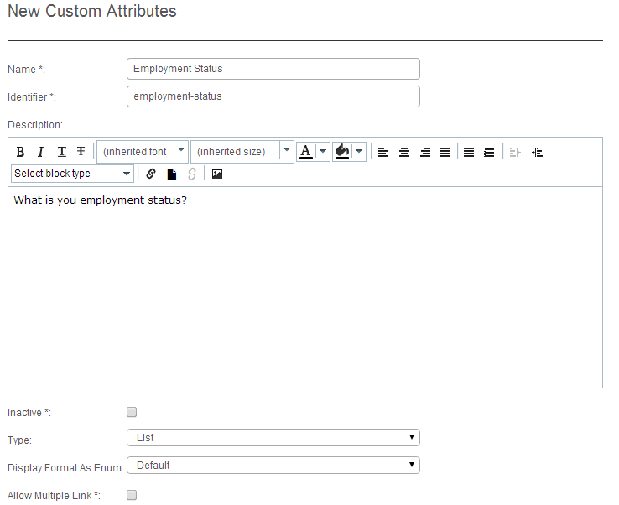
Custom attributes are a powerful method of gathering extra information about a learner or enrolment without needing to get the developer to create custom forms etc.
A custom attribute is basically a field in the database that the administrator can add. For example, if you want to ask the learner how they heard about your website, you could create a custom attribute with a list of options like “Friend, Newspaper, Internet Search, TV” and then assign that to the site registration page.
You could also re-use that custom attribute on the enrolment form, so that you can re-ask the question every time they enrol in a course on your portal.
Custom attributes can also be collected into groups for easy management. In Australia for example, if you offer Vocational Education and Training (VET) you must collect a specified set of data about your learners called AVETMIS.
You could create a custom attribute set called AVETMIS 7.0 and apply it to every vocational course in your system and not assign it to other courses.

Key features:
Supported fields for custom attributes include:
- List (can have multiple selections)
- Boolean
- String
- Selection
- Selection with other
- Memo
- Integer
- Floating Point
- Date
List items can have editable Names, Identifiers and Values

Constraints
- At this stage custom attribute sets cannot be exported or imported from one portal to another but this is planned for future development.

Custom pricing
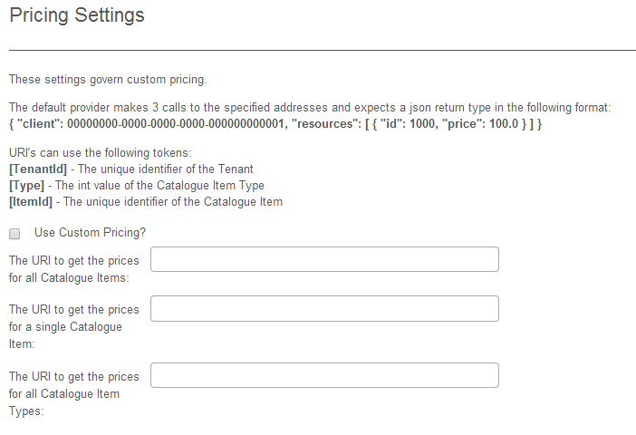
Often you will not want to use a set pricing model on the CLS, but pull the pricing from another system your organisation uses to manage training.
The Custom pricing option allows you to create a secure link between the CLS and another pricing system.
Once the CLS has been configured with the correct OAuth certificates to communicate with the pricing server, it will makes calls to the pricing server when a learner seeks enrolment.
The pricing server sends back a JSON string which contains the catalogue item identifier and the price.

Key features:
- Set a custom pricing URL for all catalogue items
- Set a custom URL for a single catalogue item
- Set a custom URL for catalogue item types
- Pass a tenant ID to the pricing server
- Pass a catalogue item type to the pricing server
- Pass the identifier of the catalogue item to the pricing server

Constraints
- Can’t pass the sub-domain to the pricing server
- Can’t pass the country of the learner to the pricing server

Create and edit email templates
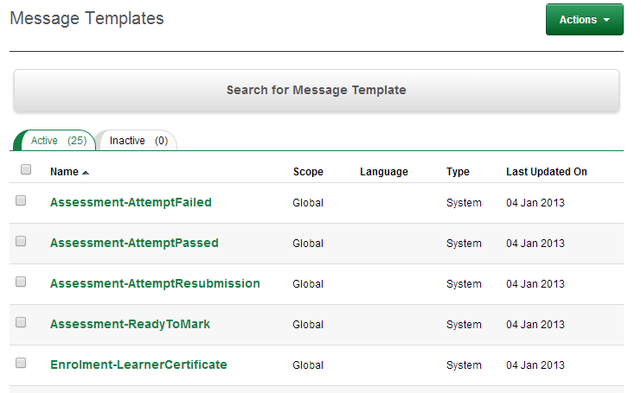
The CLS sends emails to people on set events like registration, enrolment and to reset passwords.
These emails can be edited by tenant administrators to contain any messages, images, and HTML required.
When developing an email template, you can send test copies of it to yourself or others to ensure the layout and content is accurate for your purposes.
By default there are 25 standard templates in a tenant. These are from the global account for your cluster and can’t be edited. If you do wish to edit one, the system will automatically make a local copy for your tenant (portal) and then allow you to edit that.

Key features:
- Each portal comes with a standard set of 25 templates including:
  - Registration
  - Enrolment
  - Forgot password
  - Completion
  - Token order request
  - Confirm email change
  - Assessment pass/fail
- Templates can contain HTML
- Tokens can be inserted into messages including:
  - Score
  - Pass mark
  - Attempt
  - Email
  - Name
  - Catalogue item
  - Address, state, postcode, country

Create language profiles
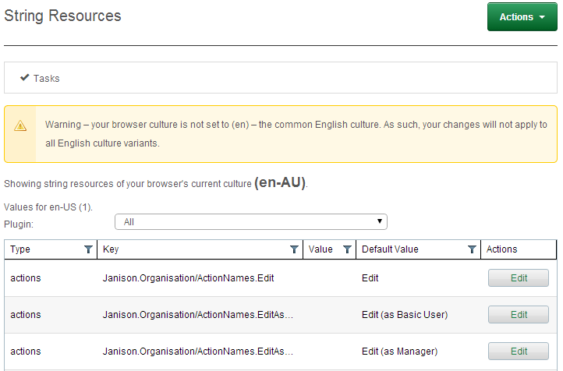
On the CLS you can create a multi-lingual version of your portal based on the learner’s culture setting in the browser. If you wish to just change some of the terminology like ‘Module’ to ‘Topic’, you can do this in the ‘String Resources’ in Settings menu.
The ‘String Resources’ settings are based on your Browser’s culture setting. This means that if you want to create a French version of the portal, you just change your browser to ’FR’ and then edit the terms in the portal that you’d like in French.
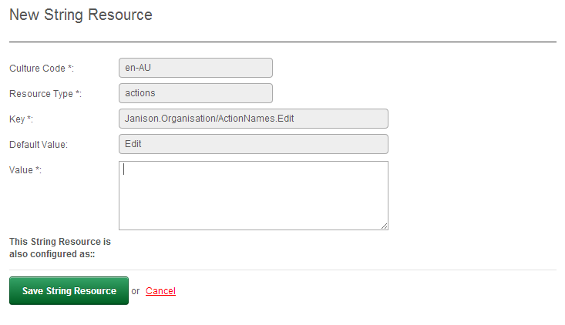
This also allows you to edit the English language version and change the common terminology in the site. For example some organisations prefer the term ‘Topic’ to ‘Module’, so you change any reference to the word ‘Module’, with ‘Topic’ in just one place. This then changes it across the whole site.
There are over 3,500 strings used so far within the CLS and every one can be changed just for your site, or changed to make a multi-lingual eLearning portal.

Key features
- Over 3,500 strings can be changed in the site.
- Create custom terms and phrases within your site to match your organisation’s language.
- Create custom languages to match you client’s browser settings.

Manage and grant RPL to learners
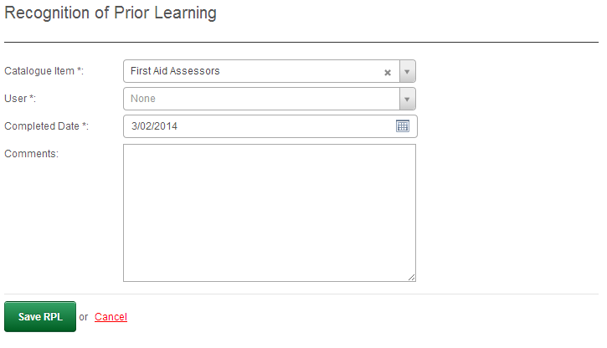
Recognition of Prior Learning (RPL) is a method for granting credit for skills already obtained and recording the evidence that was provided by the individual to support their claim for RPL.
RPL is most commonly used in the Australian Vocational Education market, but can also be used within workplaces to say, for example, ‘Yes, this person has sales skills’.

Key features:
- Automatically enrols a user in a course and grants RPL in the one process.
- Allows the admin to enter information to support the RPL process.

Create and manage content providers
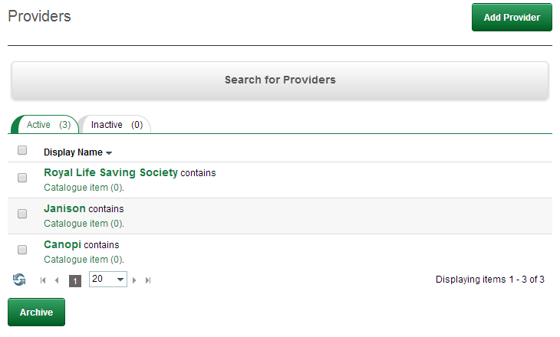
When you create a Catalogue item on the portal, you can assign it a provider for reporting purposes. For example, you might have courses from a National Office and some courses from different State bodies.
The provider system allows you to identify the provider of the course so that you can report and/or assign assessors based on the information in the ‘Provider’ field.
As the number of providers increases on the Janison network, this field will enable one tenant to share content with other tenants and provide assessment services.

Key features:
- Allows a list of courseware providers to be managed
- Allows a provider to be linked to a catalogue item

Manage site authorisation
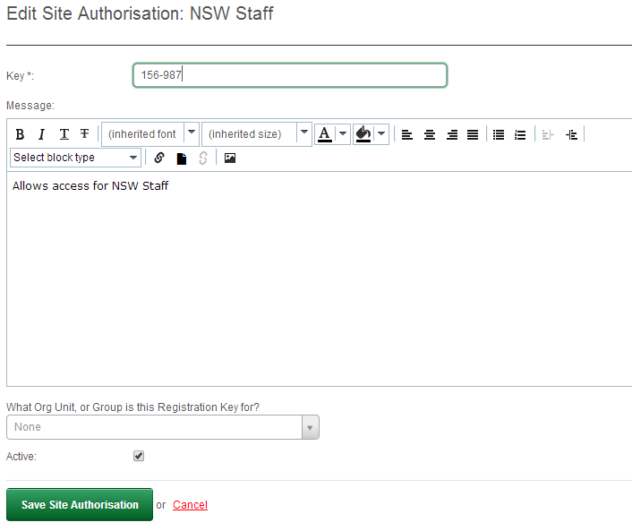
Site authorisation allows an administrator to create a private key (code) that will lock out registration if the user does not have the key.
You can also create custom enrolment rules with this that force users into certain courses based on their use of a key.
If you enable self-registration on your portal but you don’t want the general public to be able to register, these keys are an effective way to lock people out.
When the user clicks on the ‘Register’ link from the login page, they will be asked to enter their registration key to gain access to the site. Once they enter a valid key, they will be allowed to enter the full registration process as normal. If they fail they will be asked to enter a valid key, or contact a system administrator.

Key features
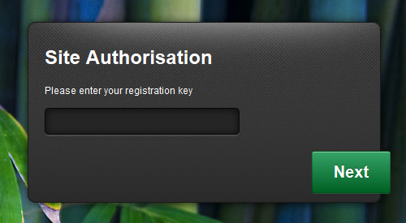
- Can modify the prompt text on the key entry page
- Can modify the incorrect key message
- Can set enrolment rules based on what key was used

Edit form registration fields
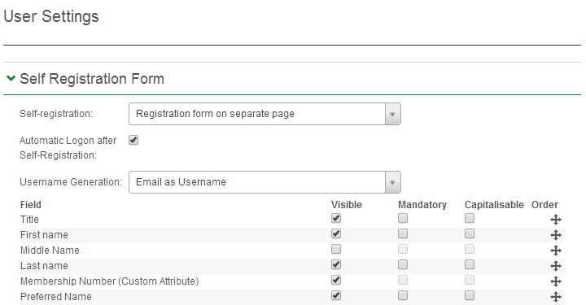
Often you need to add or edit some of the fields on the registration or user management page to capture exactly what you need to know about your learners.
There are two ways to do this in the CLS.
- Edit an existing user field
- Create a custom attribute
If the field is already in the user profile list (like Surname) for example, and you want to rename it to ‘Family Name’ then you’d edit the String Resource as above. If on the other hand you want to create a new field called ‘Membership Number’ so that people have to enter it when they register, you’d create a custom attribute and assign it the ‘Learner Domain’
When you then edit the ‘Registration’ setting you can make these fields visible, mandatory, or capitalised.
An important feature of the user management structure is that you can set fields to be in-visible on the registration form but then enable them on the ‘Edit Form’. This means that if someone edits their profile, then they are required to add a photo for example, or enter a postal address.
The domains for different visibility of user details are:
- Self-registration form
- Edit details form (when a user edits their own details)
- List form (when showing a grid view of all learners)
- Details page (when others view their details)
- Public profile (when other learners search them)
In effect, you choose in what context you want certain fields visible and editable in the system.

Key features:
- Case sensitive for passwords
- Not case sensitive for user ID
- Editing existing registration fields
- Create new registration fields
- Set any field as visible
- Set any field as mandatory
- Set any field as capitalised
- Reorder existing and/or new fields amongst each other

Create custom workflows
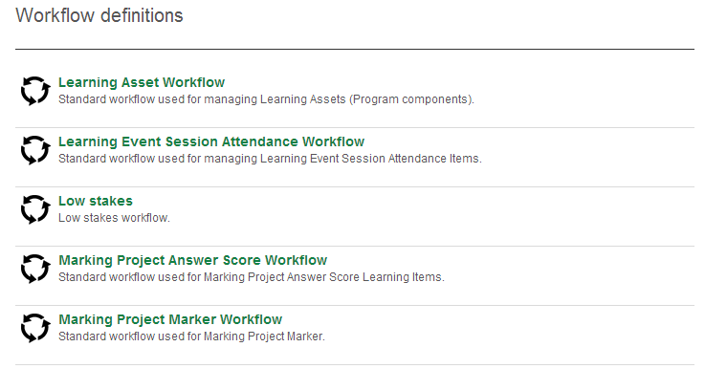
The CLS comes configured with many standard workflows for enrolment, assessment and marking.
If these don’t meet your needs, the system can be configured with custom workflows. You may, for example, want all assessments that have been submitted for marking to be reviewed by a moderator. The system allows you to assign these assignments to a marker and then a moderator.
The modification of workflows is a complicated process so it’s best to map your workflow requirements and then get Janison to modify them for your portal.

Key features:
- Supports multiple states for different domains, the domains include:
  - Registration
  - Enrolment
  - Assessments
- Supports multiple states per domain, for example:
  - Not started
  - Started
  - Not complete
  - Pass failed
  - Pending review
  - Pending marking

Constraints:
- Workflows are not client configurable

Create and edit terms of use
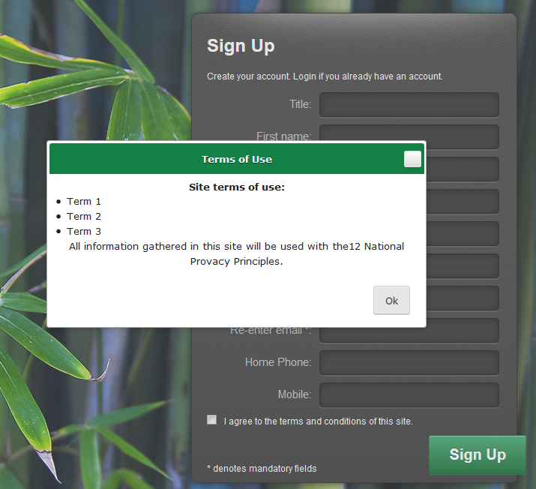
‘Terms of Use’ is a common requirement before people create an account. It is good practice and in line with the privacy principles to ensure that learners read and agree to your ‘Terms of Use’.
The Terms of Use function, when enabled, adds a field onto the registration page that asks the person to agree to the Terms of Use, and provides them with a hyperlink to view them. If they select the hyperlink, the Terms of Use appear in a pop-up dialogue box.
Portal administrators can enable, create and edit the Terms of Use in the ‘Settings’ menu.
If you have Terms of Use on your website, you may prefer to direct the learner towards those so you don’t have to maintain two sets of information. In the settings screen you can provide a URL to link to ‘Terms of Use’ in a window on your website.

Key features:
- Enable and disable Terms of Use on the registration page
- Edit the text of the Terms of Use
- Replace the text with a dedicated URL

Constraints:
While the text editor has the ability to format the text using HTML, you cannot directly edit the HTML.

