Panel templates

Plain text
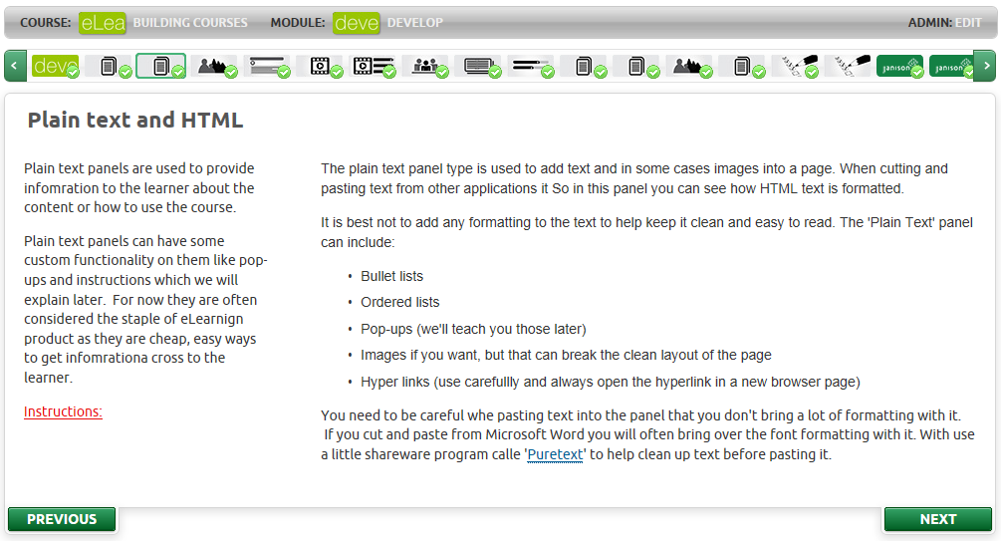
A text panel allows for HTML text to be displayed within a panel.
The HTML can contain:
- Pop-up dialogue boxes
- A ‘Click’ to manually complete the page
- Reveal bullet and ordered lists
- Normal bullet and ordered lists
- Hyperlinks
- JavaScript and other client side scripting
- CSS styles
- Bold and italicised text
- Images

Accordion/tab
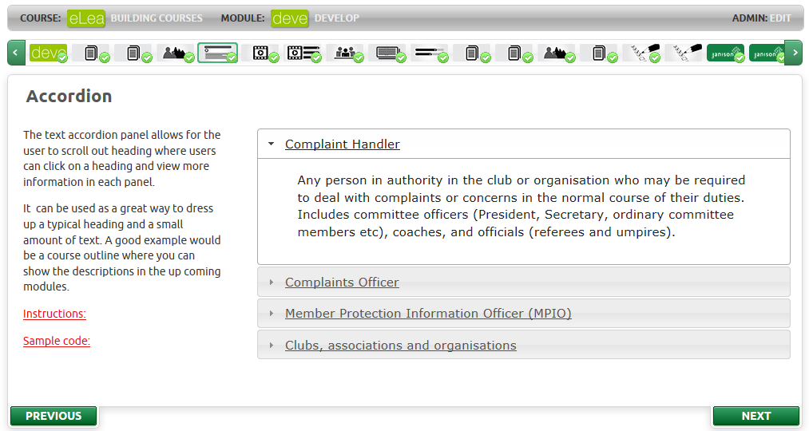
Accordion panels group content by headings and can display as either accordion headings, vertical tabs, or horizontal tabs.
An accordion panel can:
- Complete when visited
- Complete when one heading is selected
- Complete when all headings have been selected
- Have accordion bars
- Have horizontal tabs
- Have vertical tabs
- Work the same in all supported browsers

Image
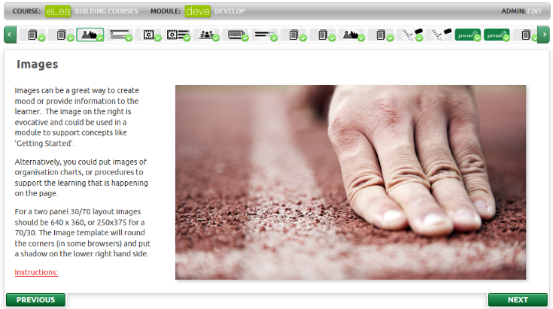
The image panel is a dedicated panel type for displaying images.
On an image panel you can:
- Display a selected image
- Resize a selected image
- Place a drop shadow on the image
- In some browsers, place curves or corners on the image
- Present ‘Alt’ text for the image

Hotspot
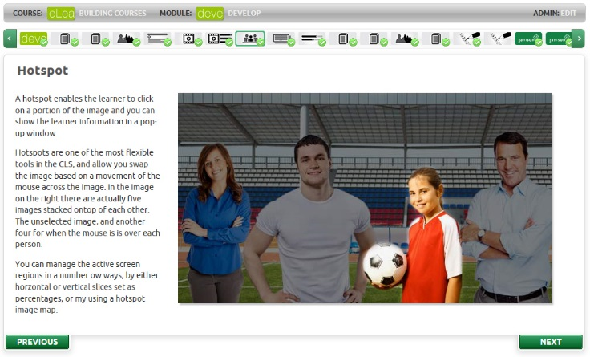
An image hotspot contains a background image with defined areas that can be highlighted when the mouse is moved over them.
When a region is selected, the screen can show a pop up.
An image hotspot can:
- Use a stacked offset image to show different images depending on the region of the screen selected
- Support x, y regions
- Support vertical slices
- Support horizontal slices
- Generate a pop-up box with HTML text when a region is clicked

360 degree hotspot
A 360 degree hotspot enables a learner to explore information about one object in relation to another object. It is presented as one large image with four clickable areas and four small images down the side.
With a 360 degree hotspot, the learner clicks one area on the main image and can then choose one of the smaller images on the right to read about the interaction between the two.

Video
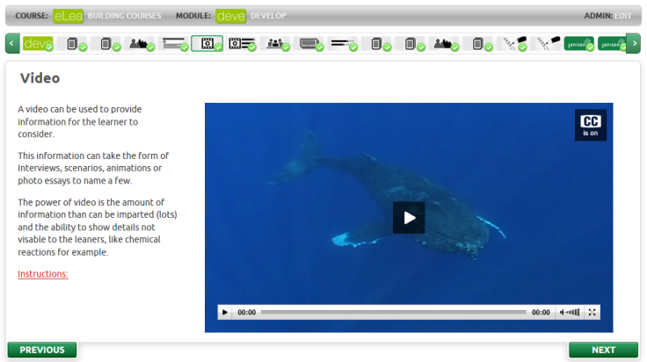
A video panel plays an encoded video with subtitles.
A video panel can:
- Play an Mp4 video encoded with the H.264 codec (this ensures tablet playback)
- Be resized, but 640 x 360 works best
- Contain a captions file
- Have ALT text
- Have a place holder image before the video starts playing

Video Case study
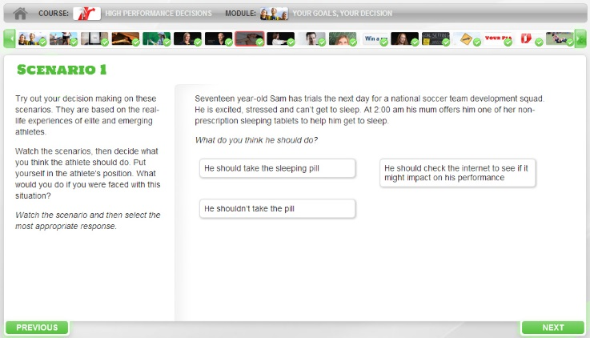
A video case study displays a series of videos. Between each one, the learner is required to answer questions that are scored correct or incorrect.
A video case study can:
- Display MP4 videos
- Have up to six distractors
- Have one correct answer
- Ask the learner to retry, or start from the beginning again.
- Mark the page the page as complete when they have answered all questions correctly.

YouTube clip
Just as you can embed a video in your eLearning, you can also include a YouTube clip.

Slideshow
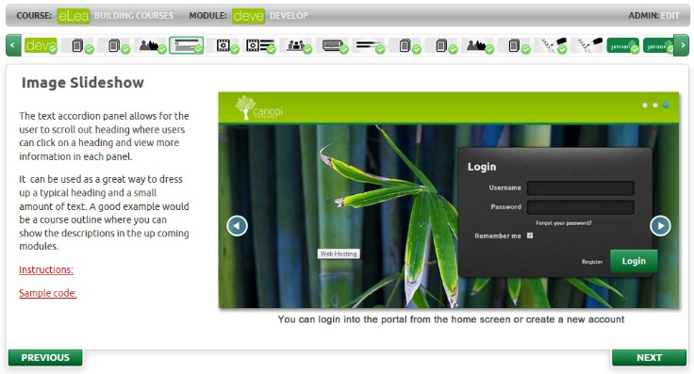
An image slideshow presents a series of images that can be navigated by the learner.
An image slideshow can:
- Show an unlimited number of images
- Fade or slide through transitions
- Fade through different colours
- Contain a caption for each slide
- Set the page to complete when viewed
- Set the page to complete when one extra slide is viewed
- Set the page to complete when all slides are viewed
- Have different times set for each transitions
- Include audio

Poll/slider bars
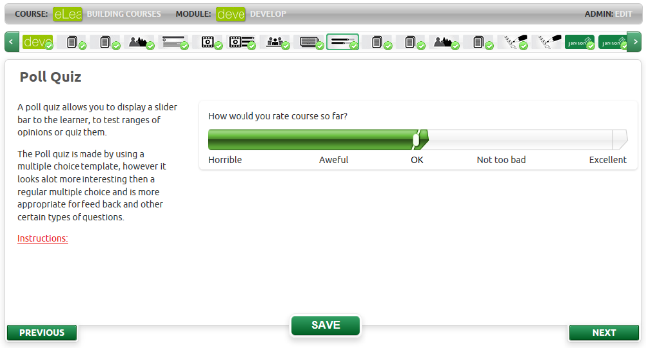
A poll/slider bar panel presents answers to a question or events on a sliding bar.
A slider bar can:
- Have up to five distractors
- Provide feedback on each selection
- Have more than one slider bar per panel (Five is about the best maximum, but there is no limit.)

2D poll
The 2D poll allows the learner to explore the relationship between two variables. Two connected scales interact to show the impact of changes in each of the variables, giving a calculated outcome.

Reflection tiles
A reflection tile presents a question, information or an image on one side of a rectangular shape and the answer, an example or an explanation on the flip side.
A reflection tile can:
- Have text on either side
- Have an image on either side
- Have the edge padding changed
- Have two possible distractors on the front
- Have different feedback based on the distractor
- Be used in a micro quiz
- Have any number of x and y tiles

Sortable list
This interactive template presents the learner with a list of items that are not ordered correctly. The learner is required to drag the items into the correct order according to requirements.

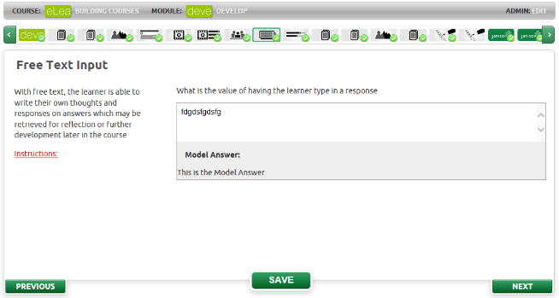
Free text input
The free text input box allows the learner to type in information for submission or self-reflection.
A model answer can be supplied to the learner after they submit their answer.
A free text input can:
- Accept an unlimited number of characters
- Provide a model answer to the learner when they click ‘Save’

Journal
The Journal template allows a learner to select the Journal tool on the right of the screen to open a dialogue box where they can enter text. This text can be saved and/or printed if required.

Micro quiz
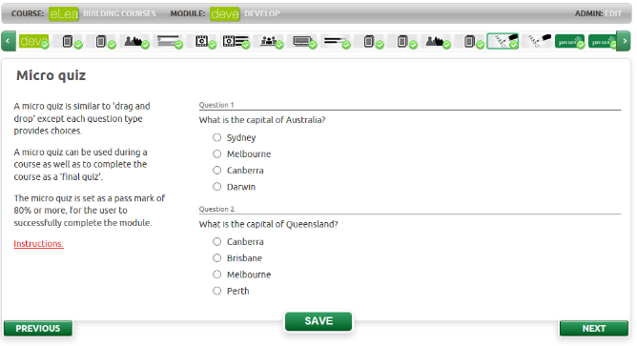
A micro quiz panel is used to ask questions.
A micro quiz can:
- Have multiple choice questions
- Have flip tile questions, but the whole quiz must contain just flip tile questions.
- Have any score as a pass mark including zero
- Provide pass/fail feedback at the quiz level
- Provide pass/fail feedback at the question level
- Be set to complete only when a learner passes the quiz

Checkbox toggle
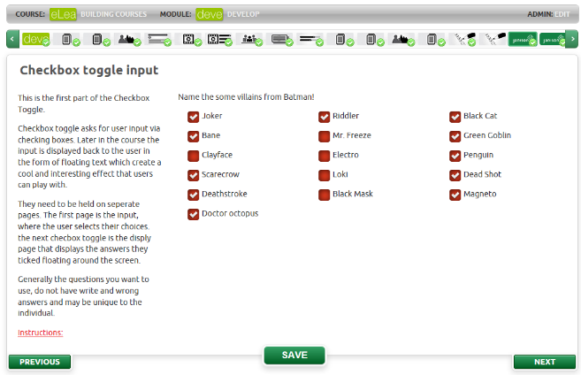
A Checkbox toggle panel asks for user input via checking boxes. This input can be displayed later in the course in the form of floating text. These make good self-reflection exercises as in “Here is what you chose earlier”.
A checkbox toggle can:
- Show an unlimited number of choices to the learner
- Have them select as many options as they want
- Play back those selections on a later page

Checkbox output
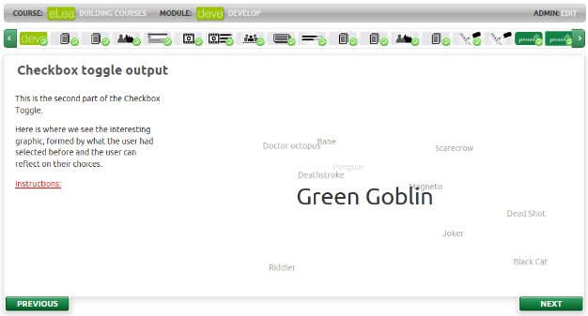
The checkbox playback panel animates the checkbox selections.
These are good self-reflection tools.
A checkbox toggle can:
- Display the choices a learner previously gave to a checkbox toggle input screen
- Animate those choices

Drag and drop
On a drag and drop panel, a learner moves information on the screen to a destination or target area.

Highchart
The highchart templates allows you to chart results from poll quizzes. There are two charts that can be displayed simultaneously, the averages chart which shows the average values from each test, and the highchart itself which shows each response to the questions. The two charts can be displayed independently of each other.

